Application Deployment Process

Author: | W. Whiteside
Version: | 1.00
Publication Date: | 02/14/05

DOCUMENT IDENTIFICATION INFORMATION
Document Name: | Application Deployment Process
Version: | 1.00
Date Created: | 4/30/2005
Created By: | William S. Whiteside
Date Published: | May 5, 2005
Security Classification: | Internal Use
Creation Software: | Microsoft Word 2000
Contributors: | Jeff Hartman, Bill Merwin, Lisa Phillips, Robert Romagnino

DISTRIBUTION LIST
DL CSC-ITS-Infrastructure and Production Application Services

DOCUMENT LOCATION
IPAS On-Call Procedure | Click here to access this document, or navigate through the following path to the public folder:  Outlook:\\public folders\all public folders\corporate service center\Information Technology Services\Systems Services\AIX - Web Infrastructure - VMS

Table Of Contents

Introduction 1
About This Document 1
Process Overview 1
Place Application Build Files On WebSphere Server 1
Deploying Application Builds Through Environments 1
FTP Application Build Files to WebSphere Server 2
Install Enterprise Application into WebSphere 3
Task Performed During Application Installation 3
Execute Application Installation Script 4
Confirm Application Is Available 4
IVR Deployment Procedure 5
Assumptions 5
E-mail Notification (Maintenance Starting) 6
Disable End-User Access 7
DBA Notification To Start Database Updates 11
Inform DBA group they can start deploying database updates 11
WebSphere JAVA Application Deployment 12
DirectTalk Beans Java Application Deployment 38
Additional Potential Maintenance Tasks 45
DBA Notification Database Updates Are Complete 48
Enable End-User Access 49
Post-Maintenance Test Procedures 55
Select Manager (Web Administration) 55
Web Assessment Module 57
IVR (Telephony) Assessment Module 58
E-Mail Notification (Maintenance Complete) 59
Appendix A. — User And Password Information 60
IVR Production System (cscx0901.core.XYZ.com) 60

Introduction
From time to time a new or modified application requires deployment throughout XYZ, or specific environments within XYZ. This document explains the requirements and the steps to be used to accommodate the deployment of an application.

About This Document
This document is divided into sections, each of which addresses the steps required for a particular application. The applications currently covered include:
- IVR Deployment Procedure — Page 5

Process Overview
This section presents a high-level explanation of specific deployment specifications:
- Place Application Build Files On WebSphere Server, Page 1
  - Deploying Application Builds Through Environments
  - FTP Application Build Files to WebSphere Server
- Install Enterprise Application into WebSphere, Page 3
  - Task Performed During Application Installation
  - Execute Application Installation Script
  - Confirm Application Is Available

Place Application Build Files On WebSphere Server
After an Application’s Build Files have been created via the Application Assembly Procedures the Application is ready to be deployed into WebSphere.

Deploying Application Builds Through Environments
The first environment the Application is installed into is DEV. Developers do Integration Testing to confirm the Application is working as expected. At this point developers decide if the Application is ready to move to QA for User Acceptance Testing OR if there are additional fixes needed, which would require another Application build and deployment into DEV.
After developer approval in DEV the same set of Application Build Files are deployed into QA. User Acceptance Testing determines if this build is moved into PRODUCTION or if additional changes/fixes need to be made. If it is determined additional changes/fixes are needed then the Application code is modified and then re-deployed into DEV as a new build. The process then begins again with the developers testing the new build.
When an Application passes User Acceptance Testing in QA, and has been approved to move into PRODUCTION, the same set of Application Build Files are deployed into PRODUCTION.

NOTE: All bug/break fixes, in any environment, must be recorded in ClearQuest.

FTP Application Build Files to WebSphere Server
The WASDeploy$ Share on server USCSSVC2 is the designated NT file system for placing versioned Application Build files. The files are placed here by the Application Assembler and are then FTPed to the appropriate AIX WebSphere servers for deployment. The AIX WebSphere server to place the files on is determined by the environment being deployed to.
On \\WASDeploy$\uscscsvc2\ there is a <appName> directory. Under this directory is are sub-directories named by version (i.e. 1_5, 2_1, etc.). The request for deployment will include the version number to be deployed.
All files in the \\WASDeploy$\uscscsvc2\<appName>\<versionNumber>, corresponding to the requested version to be deployed, are FTPed to the WebSphere server.

Current Servers For File Placement
DEV | CSCX0106
QA | CSCX0107
PRODUCTION | CSCX0102

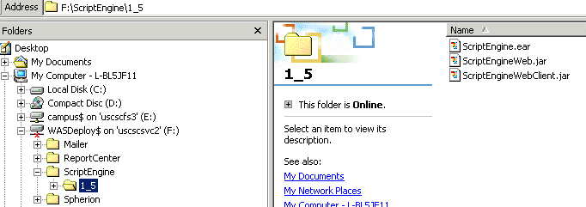

The target directory on the WebSphere server is /local/WebSphere/deploy/<appName>.

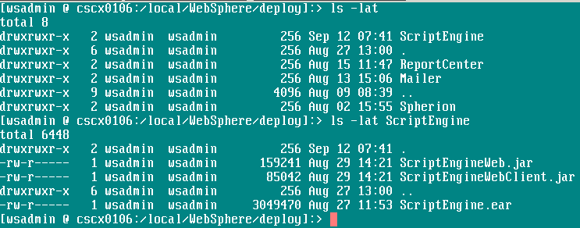

After files have been placed on the WebSphere server the Application deployment/install script can be executed.

Install Enterprise Application into WebSphere
WebSphere Application components (ServerGroups, VirtualHost, DataSources, JDBCDrivers, etc) must exist before installing the Enterprise Application. See document “Application Components Install Procedures” for more information.

Task Performed During Application Installation
The following list the task performed during the Application Installation.
- Backup current Application EAR via WebSphere’s EARExpander.sh script
- Create ContextRoot directory under Application’s Document Root for each WebApp on Web Server(s)
- SFTP Web Server .JAR file(s) to their respective ContextRoot directory
- SFTP AppServer .EAR file to remote WebSphere Nodes in the repository
- Stop current EnterpriseApplication
- Stop ServerGroup for EnterpriseApplication
- Install EnterpriseApplication on local node
- Expand .EAR for Enterprise Application on remote WebSphere Nodes in the repository
- SSH and un-jar WebServer .JAR file(s) on WebServer(s)
- Start ServerGroup for Enterprise Application
- Backup current plugin-cfg.xml on both App and Web Server(s)
- Re-gen Web Server Plugin
- Edit plugin-cfg.xml for Web Server
- SFTP plugin-cfg.xml to Web Server(s)

Execute Application Installation Script
Telnet into the WebSphere Application server and login as WSADMIN. The $SCRIPTS directory is in the PATH, so scripts can be executed from any directory.
Execute the following command to start the Application installation/deployment:

installEntApp <appName>

Confirm Application Is Available
Confirm the Application is available and working as expected by going to the URL of the Application.

IVR Deployment Procedure
This section provides the necessary steps for deploying the IVR application. The content addresses the following:

E-mail Notification (Maintenance Starting), Page 6
Disable End-User Access, Page 7
DBA Notification To Start Database Updates, Page 11
WebSphere JAVA Application Deployment, Page 12
DirectTalk Beans Java Application Deployment, Page 38
Additional Potential Maintenance Tasks, Page 45
DBA Notification Database Updates Are Complete, Page 48
Enable End-User Access, Page 49
Post-Maintenance Test Procedures, Page 55
E-Mail Notification (Maintenance Complete), Page 59
Appendix A, Page 60

Assumptions
It is assumed that the users of this document are knowledgeable in the areas of:
- WebSphere
- Rational Unified Process (RUP)

E-mail Notification (Maintenance Starting)
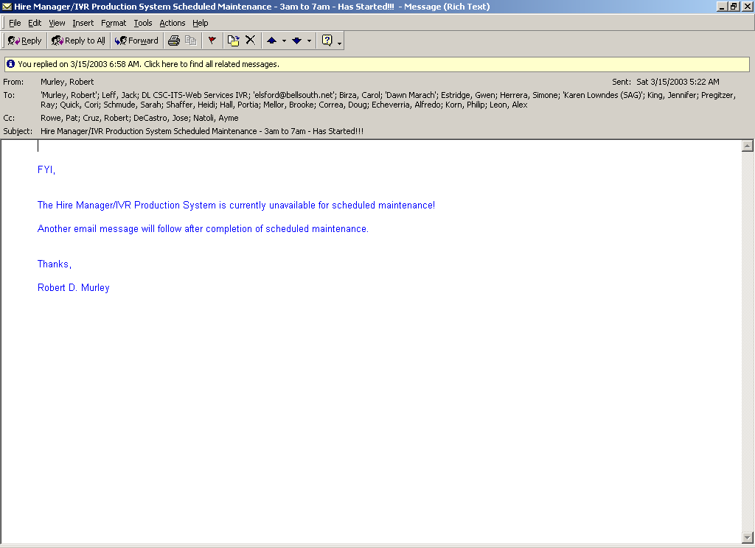

-----Original Message-----
From: Murley, Robert
Sent: Saturday, March 15, 2003 5:22 AM
To: 'Murley, Robert'; Leff, Jack; DL CSC-ITS-Web Services IVR; 'elsford@bellsouth.net'; Birza, Carol; 'Dawn Marach'; Estridge, Gwen; Herrera, Simone; 'Karen Lowndes (SAG)'; King, Jennifer; Pregitzer, Ray; Quick, Cori; Schmude, Sarah; Shaffer, Heidi; Hall, Portia; Mellor, Brooke; Correa, Doug; Echeverria, Alfredo; Korn, Philip; Leon, Alex
Cc: Rowe, Pat; Cruz, Robert; DeCastro, Jose; Natoli, Ayme
Subject: Select Manager/IVR Production System Scheduled Maintenance - 3am to 7am - Has Started!!!

Disable End-User Access
- Stop web servers (uscscweb13 and uscscweb14) to disable end-user web access
NOTE: Perform this task as root user. Also, SSH from IVR production box (cscx0901) to web servers (uscscweb13 and uscscweb14) in the DMZ when using a remote VPN connection.

[wsadmin @ cscx0901:/wshome/wsadmin]:> ssh uscscweb13
Last login: Fri Mar 21 12:42:17 2003 from 10.12.77.75
[wsadmin@uscscweb13 wsadmin]$ su -
Password:
[root@uscscweb13 root]#

[wsadmin @ cscx0901:/wshome/wsadmin]:> ssh uscscweb14
Last login: Fri Mar 21 12:42:17 2003 from 10.12.77.75
[wsadmin@uscscweb14 wsadmin]$ su -
Password:
[root@uscscweb14 root]#

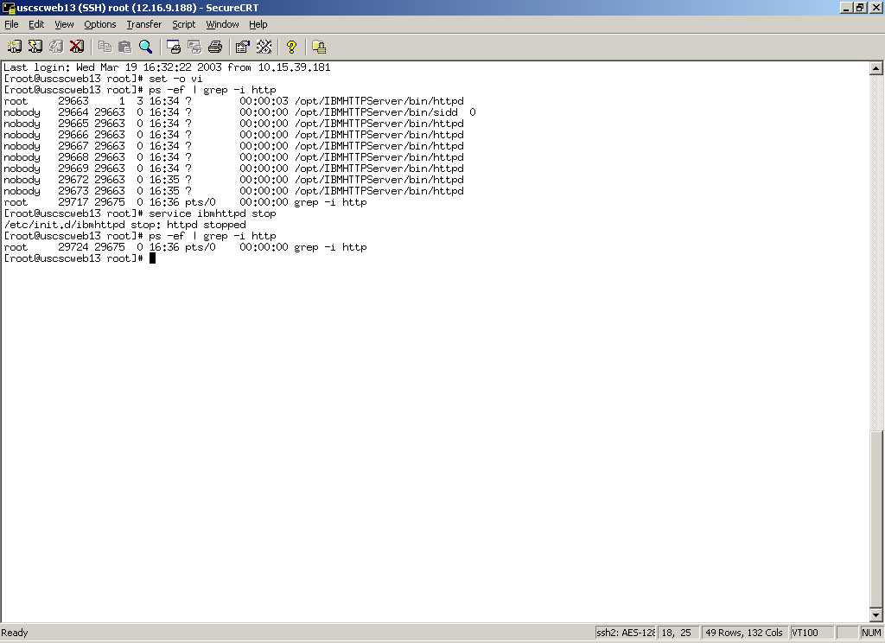

Last login: Wed Mar 19 16:32:22 2003 from 10.15.39.181
[root@uscscweb13 root]# set -o vi
[root@uscscweb13 root]# ps -ef | grep -i http
root 29663 1 3 16:34 ? 00:00:03 /opt/IBMHTTPServer/bin/httpd
nobody 29664 29663 0 16:34 ? 00:00:00 /opt/IBMHTTPServer/bin/sidd 0
nobody 29665 29663 0 16:34 ? 00:00:00 /opt/IBMHTTPServer/bin/httpd
nobody 29666 29663 0 16:34 ? 00:00:00 /opt/IBMHTTPServer/bin/httpd
nobody 29667 29663 0 16:34 ? 00:00:00 /opt/IBMHTTPServer/bin/httpd
nobody 29668 29663 0 16:34 ? 00:00:00 /opt/IBMHTTPServer/bin/httpd
nobody 29669 29663 0 16:34 ? 00:00:00 /opt/IBMHTTPServer/bin/httpd
nobody 29672 29663 0 16:35 ? 00:00:00 /opt/IBMHTTPServer/bin/httpd
nobody 29673 29663 0 16:35 ? 00:00:00 /opt/IBMHTTPServer/bin/httpd
root 29717 29675 0 16:36 pts/0 00:00:00 grep -i http
[root@uscscweb13 root]# service ibmhttpd stop
/etc/init.d/ibmhttpd stop: httpd stopped
[root@uscscweb13 root]# ps -ef | grep -i http
root 29724 29675 0 16:36 pts/0 00:00:00 grep -i http
[root@uscscweb13 root]#

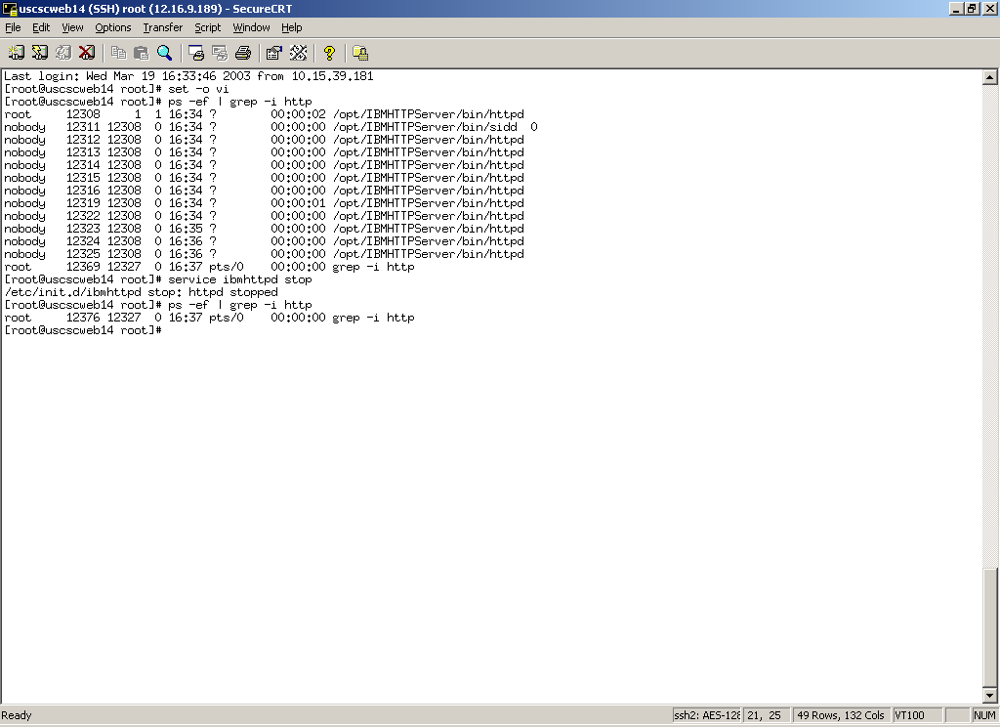

Last login: Wed Mar 19 16:33:46 2003 from 10.15.39.181
[root@uscscweb14 root]# set -o vi
[root@uscscweb14 root]# ps -ef | grep -i http
root 12308 1 1 16:34 ? 00:00:02 /opt/IBMHTTPServer/bin/httpd
nobody 12311 12308 0 16:34 ? 00:00:00 /opt/IBMHTTPServer/bin/sidd 0
nobody 12312 12308 0 16:34 ? 00:00:00 /opt/IBMHTTPServer/bin/httpd
nobody 12313 12308 0 16:34 ? 00:00:00 /opt/IBMHTTPServer/bin/httpd
nobody 12314 12308 0 16:34 ? 00:00:00 /opt/IBMHTTPServer/bin/httpd
nobody 12315 12308 0 16:34 ? 00:00:00 /opt/IBMHTTPServer/bin/httpd
nobody 12316 12308 0 16:34 ? 00:00:00 /opt/IBMHTTPServer/bin/httpd
nobody 12319 12308 0 16:34 ? 00:00:01 /opt/IBMHTTPServer/bin/httpd
nobody 12322 12308 0 16:34 ? 00:00:00 /opt/IBMHTTPServer/bin/httpd
nobody 12323 12308 0 16:35 ? 00:00:00 /opt/IBMHTTPServer/bin/httpd
nobody 12324 12308 0 16:36 ? 00:00:00 /opt/IBMHTTPServer/bin/httpd
nobody 12325 12308 0 16:36 ? 00:00:00 /opt/IBMHTTPServer/bin/httpd
root 12369 12327 0 16:37 pts/0 00:00:00 grep -i http
[root@uscscweb14 root]# service ibmhttpd stop
/etc/init.d/ibmhttpd stop: httpd stopped
[root@uscscweb14 root]# ps -ef | grep -i http
root 12376 12327 0 16:37 pts/0 00:00:00 grep -i http
[root@uscscweb14 root]#

- Stop DirTalk Beans environment to disable end-user telephony access

NOTE: Perform this task as dtuser. Also, running DTBE process is shown in blue.

[dtuser@cscx0901:/home/dtuser]:> ps -fu dtuser | grep -i java
dtuser 14524 79220 0 06:39:51 - 0:04 /usr/java130/jre/bin/java -Xoss800K -DDTJ_PROCNAME=Node1 -Ddtj.home=/var/dirTalk/DTBE -Dsun.rmi.transport.tcp.connectionPool=true -classpath /var/dirTalk/DTBE/nls/mappers/ibmlang.jar:/var/dirTalk/DTBE/server/plugins/ViaVoice/ibmvv.jar:/var/dirTalk/DTBE/server/xerces.jar:/home/dtdb23in/sqllib/function:/home/dtdb23in/sqllib/java/db2java.zip:/home/dtdb23in/sqllib/java/runtime.zip:/home/dtuser/system/record/remote.jar:/home/dtuser/system/record/j2ee.jar:/home/dtuser/system/core/core.jar:/home/dtuser/system/lib/TestApp.jar:/home/dtuser/system/lib/XYZ.jar:/home/dtuser/system/lib/j2eetools.jar:/home/dtuser/system/lib/ivjejb35.jar:/home/dtuser/system/lib/websphere.jar:/home/dtuser/system/lib/ns.jar:/home/dtuser/system/lib/utils.jar:/home/dtuser/system/lib/bootstrap.jar:/home/dtuser/system/lib/ujc.jar:/home/dtuser/system/lib/ras.jar:/home/dtuser/system/lib/iwsorb.jar:/home/dtuser/system/lib/ibmivrx.jar:/home/dtuser/system/lib/ScriptEngine.jar:/home/dtuser/system/lib/TestApp.jar:/home/dtuser/system/lib/Transfer.jar:/home/dtuser/system/lib/Inapp.jar:/home/dtuser/system/lib/CAdmin.jar::/var/dirTalk/DTBE/server/ibmdtalk.jar:/var/dirTalk/DTBE/server/ibmdtext.jar:/var/dirTalk/DTBE/server/ibmcctl.jar:/var/dirTalk/DTBE/server/ibmcpath.jar:/var/dirTalk/DTBE/server/xerces.jar:/var/dirTalk/DTBE/server/ssl.jar com.ibm.telephony.directtalk.ApplicationManagerImpl LocalHost Node1
dtuser 79220 1 0 06:39:38 - 0:02 java -Ddtj.home=/var/dirTalk/DTBE com.ibm.telephony.directtalk.HostManagerImpl
dtuser 83360 95162 1 06:43:18 pts/5 0:00 grep -i java
[dtuser@cscx0901:/home/dtuser]:>

[dtuser@cscx0901:/home/dtuser]:> dtjstop
Running the PlexManager to stop the LocalHost ...
2003.03.15 05:33:41 I DTJ3031 Stopping node Node1 at host LocalHost.
2003.03.15 05:34:11 I DTJ3013 Node Node1 at host LocalHost has stopped.
[dtuser@cscx0901:/home/dtuser]:>

NOTE 1: The dtjstop command is a queisce stop command. You may have to terminate the DTBE (DirectTalk Beans Environment) if the dtjstop command waits too long for telephony users on the system to end the call. The dtjterm DTBE shown below.
NOTE 2: Control + C was used to break out of the original dtjstop command execution.

[dtuser@cscx0901:/home/dtuser]:> dtjstop
Running the PlexManager to stop the LocalHost ...
2003.03.15 05:36:41 I DTJ3031 Stopping node Node1 at host LocalHost.
^C[dtuser@cscx0901:/home/dtuser]:> dtjterm
2003.03.15 05:41:06 I DTJ3014 Node Node1 at host LocalHost has terminated.
[dtuser@cscx0901:/home/dtuser]:>

[dtuser@cscx0901:/home/dtuser]:> ps -fu dtuser | grep -i java
dtuser 79220 1 0 06:39:38 - 0:02 java -Ddtj.home=/var/dirTalk/DTBE com.ibm.telephony.directtalk.HostManagerImpl
dtuser 83360 95162 1 06:43:18 pts/5 0:00 grep -i java
[dtuser@cscx0901:/home/dtuser]:>

DBA Notification To Start Database Updates

NOTE: We have currently been working with Wadsworth S. Riley for IVR production database support.

Inform DBA group they can start deploying database updates
This has been done via telephone with Wadsworth (cellular) so far!

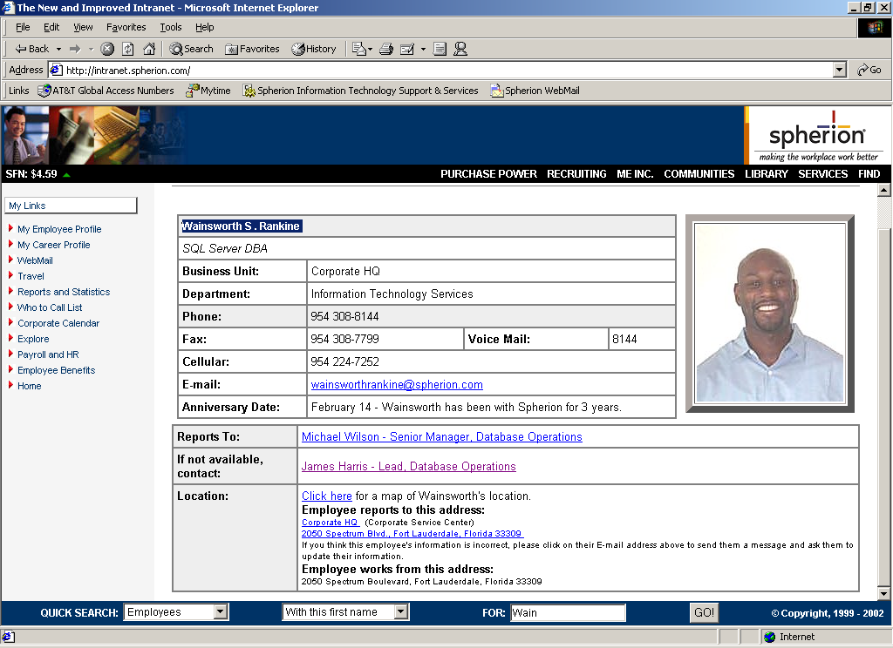
http://intranet.XYZ.com
XYZ

NO
PHOTO
Wadsworth S. Riley

WebSphere JAVA Application Deployment
- Locate new ScriptEngine and ScriptProfiler deployment EAR file(s)

NOTE: This should be done from office during normal business hours and not over remote VPN connection if possible before performing maintenance work after hours. This could take more than 30 minutes over VPN connection.

The deployment EAR file(s) are located in the following \\uscscsvc2\wasdeploy$ network share:

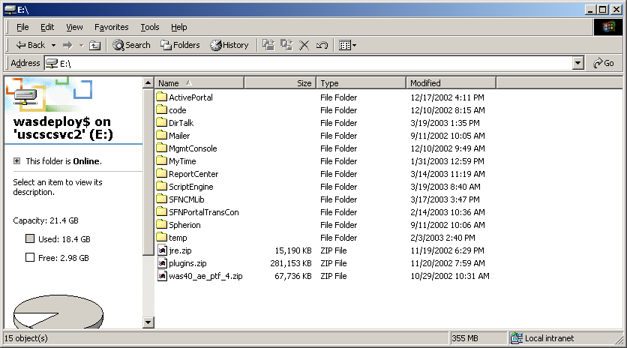

Inside the ScriptEngine folder shown below:

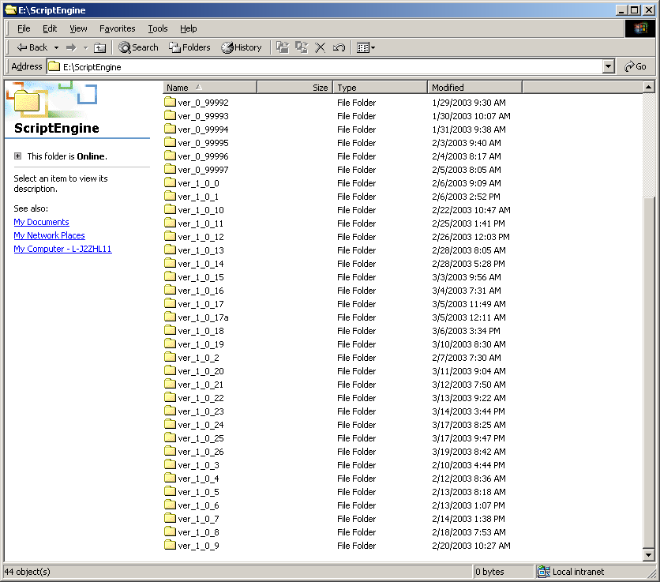

Choose appropriate deployment version (ver_1_0_26 as an example) shown below:

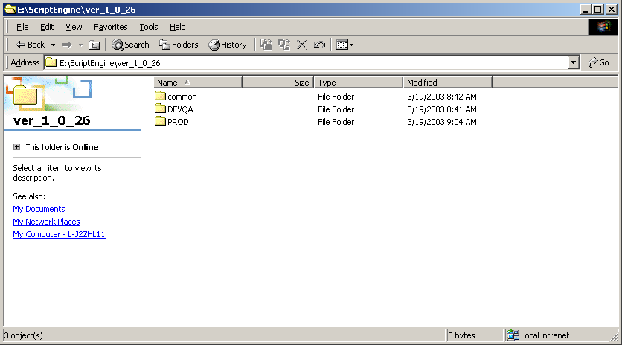

Use the common and PROD folders for production deployments shown below:

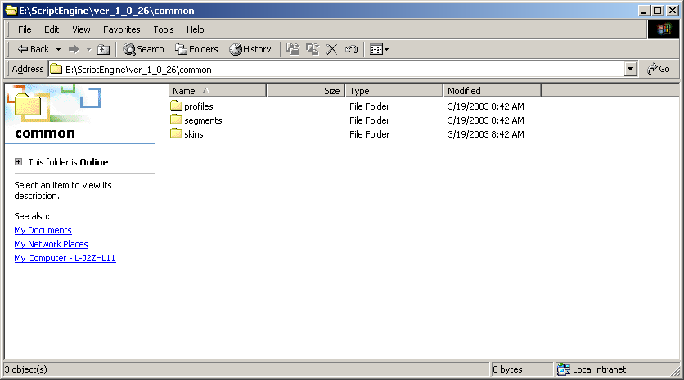

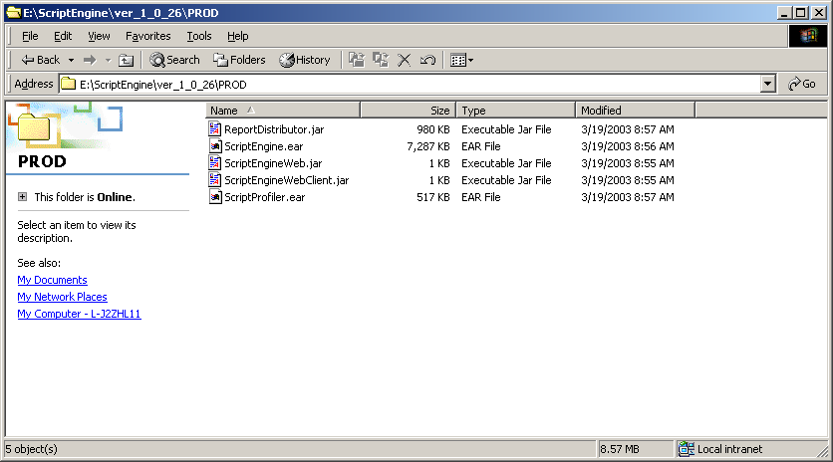

- FTP the appropriate file(s) to IVR production system.

NOTE: We currently ftp the appropriate deployment version files for ScriptEngine and ScriptProfiler to the IVR production system using our SecureFX tool as wsadmin.
- Common directory updates:
Place common directory updates in the /local/WebSphere/deploy/ScriptEngine directory on IVR production server (cscx0901) shown below:

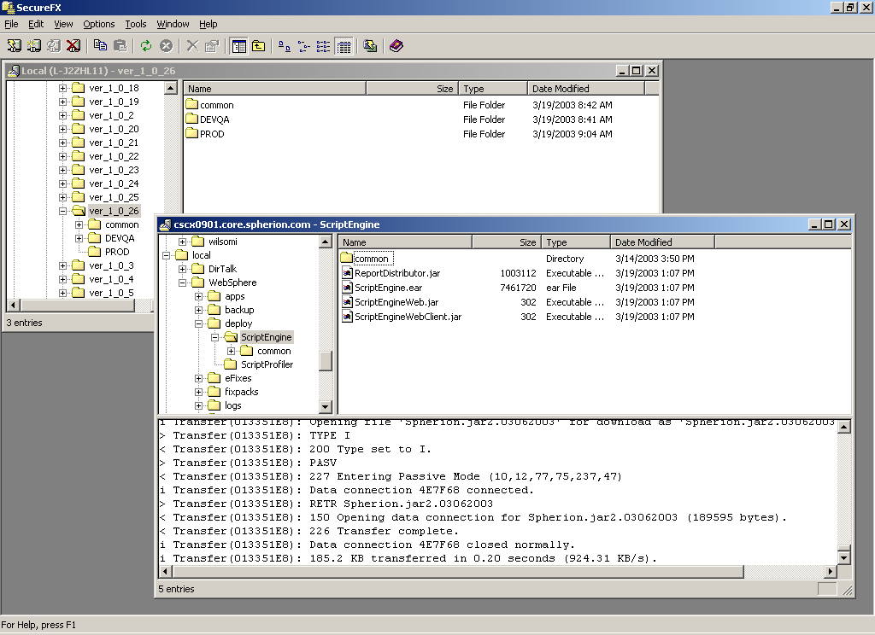

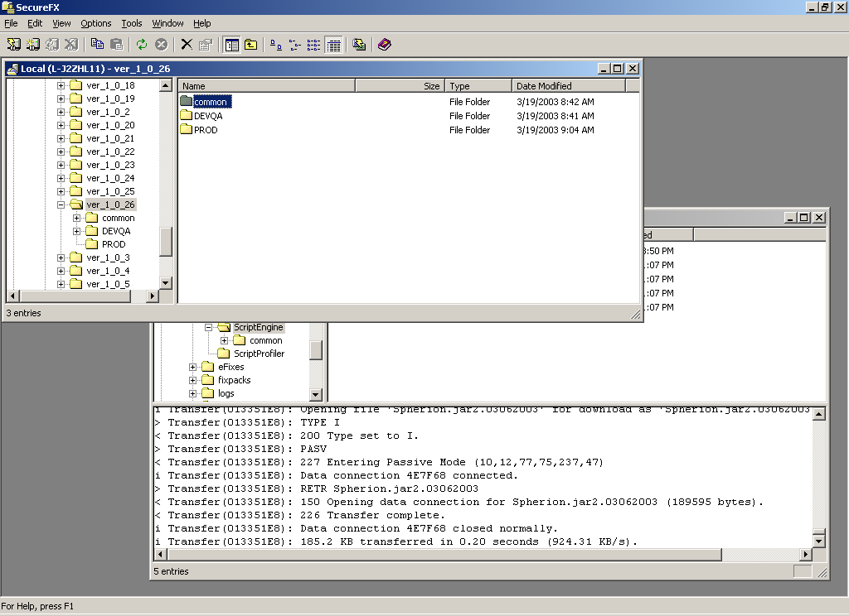

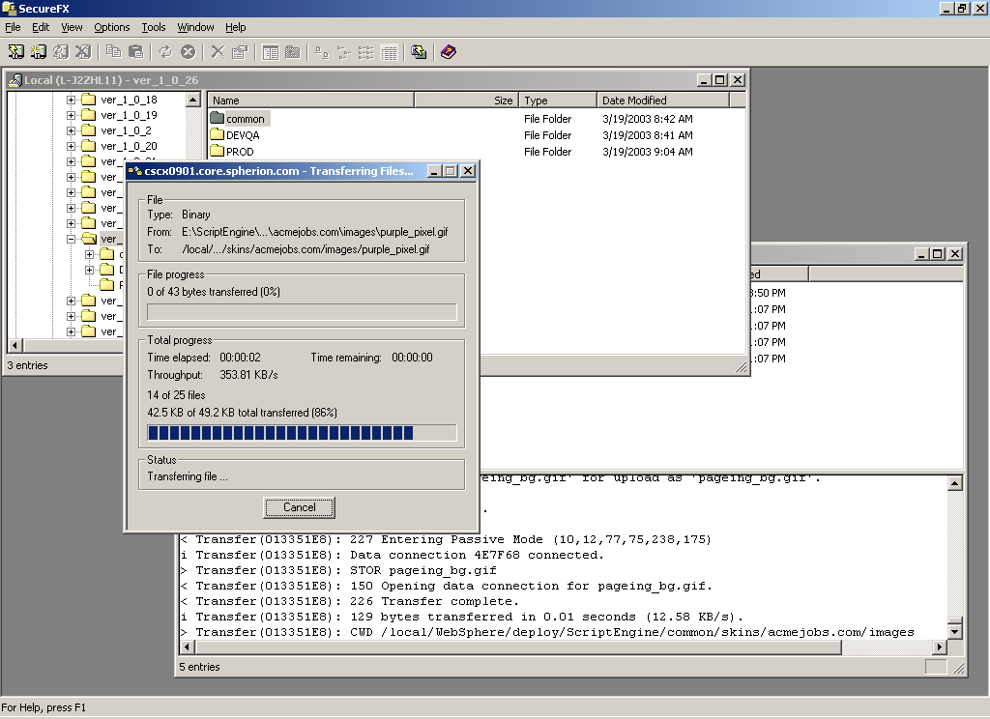

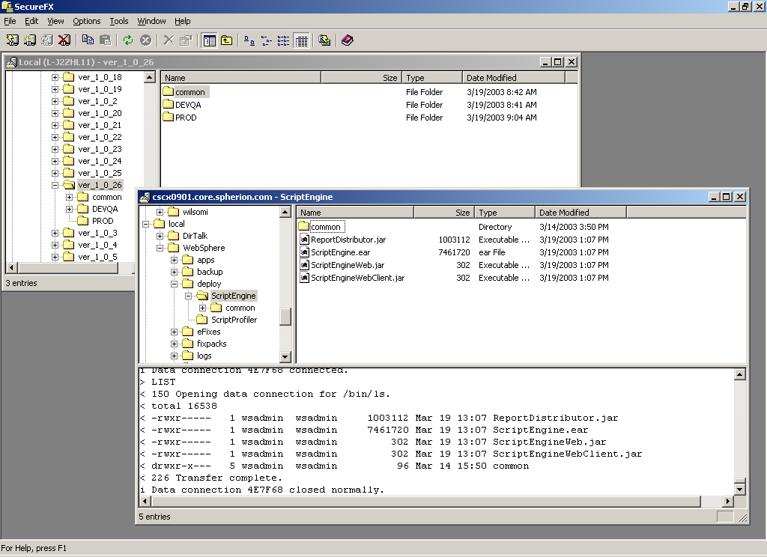

- Check date and time of common directory updates

NOTE: You will see new files with ftp date and time stamp.

Here is an example for the 03/19/03 ftp of common directory updates:

[wsadmin @ cscx0901:/wshome/wsadmin]:> cd /local/WebSphere/deploy/ScriptEngine/common
[wsadmin @ cscx0901:/local/WebSphere/deploy/ScriptEngine/common]:> find . -exec ls -alt {} \; | grep -i "Mar 19"
drwxr-x--- 3 wsadmin wsadmin 1024 Mar 19 12:49 ..
-rw-r----- 1 wsadmin wsadmin 8618 Mar 19 13:44 CandidateProfile.xsd
-rw-r----- 1 wsadmin wsadmin 8618 Mar 19 13:44 ./profiles/CandidateProfile.xsd
-rw-r----- 1 wsadmin wsadmin 6605 Mar 19 13:45 CandidateProfileDefault.xsl
-rw-r----- 1 wsadmin wsadmin 5597 Mar 19 13:45 Candidate_3525.xsl
-rw-r----- 1 wsadmin wsadmin 5280 Mar 19 13:45 Candidate_3922.xsl
-rw-r----- 1 wsadmin wsadmin 8100 Mar 19 13:45 Candidate_3955.xsl
-rw-r----- 1 wsadmin wsadmin 224 Mar 19 13:45 Candidate_4006.xsl
-rw-r----- 1 wsadmin wsadmin 179 Mar 19 13:45 Candidate_4097.xsl
-rw-r----- 1 wsadmin wsadmin 6605 Mar 19 13:45 ./profiles/xsl/CandidateProfileDefault.xsl
-rw-r----- 1 wsadmin wsadmin 5597 Mar 19 13:45 ./profiles/xsl/Candidate_3525.xsl
-rw-r----- 1 wsadmin wsadmin 5280 Mar 19 13:45 ./profiles/xsl/Candidate_3922.xsl
-rw-r----- 1 wsadmin wsadmin 8100 Mar 19 13:45 ./profiles/xsl/Candidate_3955.xsl
-rw-r----- 1 wsadmin wsadmin 224 Mar 19 13:45 ./profiles/xsl/Candidate_4006.xsl
-rw-r----- 1 wsadmin wsadmin 179 Mar 19 13:45 ./profiles/xsl/Candidate_4097.xsl
-rw-r----- 1 wsadmin wsadmin 534 Mar 19 13:45 NameAddress.xsl
-rw-r----- 1 wsadmin wsadmin 2399 Mar 19 13:45 Question.xsl
-rw-r----- 1 wsadmin wsadmin 1011 Mar 19 13:45 QuestionGroup.xsl
-rw-r----- 1 wsadmin wsadmin 1049 Mar 19 13:45 Rank.xsl
-rw-r----- 1 wsadmin wsadmin 2031 Mar 19 13:45 T2.xsl
-rw-r----- 1 wsadmin wsadmin 592 Mar 19 13:45 keys.xsl
-rw-r----- 1 wsadmin wsadmin 592 Mar 19 13:45 ./profiles/xsl/lib/keys.xsl
-rw-r----- 1 wsadmin wsadmin 534 Mar 19 13:45 ./profiles/xsl/lib/NameAddress.xsl
-rw-r----- 1 wsadmin wsadmin 2399 Mar 19 13:45 ./profiles/xsl/lib/Question.xsl
-rw-r----- 1 wsadmin wsadmin 1011 Mar 19 13:45 ./profiles/xsl/lib/QuestionGroup.xsl
-rw-r----- 1 wsadmin wsadmin 1049 Mar 19 13:45 ./profiles/xsl/lib/Rank.xsl
-rw-r----- 1 wsadmin wsadmin 2031 Mar 19 13:45 ./profiles/xsl/lib/T2.xsl
-rw-r----- 1 wsadmin wsadmin 1100 Mar 19 13:45 index.html
-rw-r----- 1 wsadmin wsadmin 2348 Mar 19 13:45 wiz_styles.css
-rw-r----- 1 wsadmin wsadmin 1514 Mar 19 13:45 wiz_window_top.gif
-rw-r----- 1 wsadmin wsadmin 129 Mar 19 13:45 pageing_bg.gif
-rw-r----- 1 wsadmin wsadmin 43 Mar 19 13:45 purple_pixel.gif
-rw-r----- 1 wsadmin wsadmin 43 Mar 19 13:45 spacer.gif
-rw-r----- 1 wsadmin wsadmin 431 Mar 19 13:45 wiz_06.gif
-rw-r----- 1 wsadmin wsadmin 286 Mar 19 13:45 wiz_content_bg.gif
-rw-r----- 1 wsadmin wsadmin 284 Mar 19 13:45 wiz_finish.gif
-rw-r----- 1 wsadmin wsadmin 306 Mar 19 13:45 wiz_next.gif
-rw-r----- 1 wsadmin wsadmin 184 Mar 19 13:45 wiz_selectall.gif
-rw-r----- 1 wsadmin wsadmin 160 Mar 19 13:45 wiz_window_bottom.gif
-rw-r----- 1 wsadmin wsadmin 129 Mar 19 13:45 ./skins/acmejobs.com/images/pageing_bg.gif
-rw-r----- 1 wsadmin wsadmin 43 Mar 19 13:45 ./skins/acmejobs.com/images/purple_pixel.gif
-rw-r----- 1 wsadmin wsadmin 43 Mar 19 13:45 ./skins/acmejobs.com/images/spacer.gif
-rw-r----- 1 wsadmin wsadmin 431 Mar 19 13:45 ./skins/acmejobs.com/images/wiz_06.gif
-rw-r----- 1 wsadmin wsadmin 286 Mar 19 13:45 ./skins/acmejobs.com/images/wiz_content_bg.gif
-rw-r----- 1 wsadmin wsadmin 284 Mar 19 13:45 ./skins/acmejobs.com/images/wiz_finish.gif
-rw-r----- 1 wsadmin wsadmin 306 Mar 19 13:45 ./skins/acmejobs.com/images/wiz_next.gif
-rw-r----- 1 wsadmin wsadmin 184 Mar 19 13:45 ./skins/acmejobs.com/images/wiz_selectall.gif
-rw-r----- 1 wsadmin wsadmin 160 Mar 19 13:45 ./skins/acmejobs.com/images/wiz_window_bottom.gif
-rw-r----- 1 wsadmin wsadmin 1514 Mar 19 13:45 ./skins/acmejobs.com/images/wiz_window_top.gif
-rw-r----- 1 wsadmin wsadmin 1100 Mar 19 13:45 ./skins/acmejobs.com/index.html
-rw-r----- 1 wsadmin wsadmin 2348 Mar 19 13:45 ./skins/acmejobs.com/wiz_styles.css
-rw-r----- 1 wsadmin wsadmin 78 Mar 19 13:45 index.html
-rw-r----- 1 wsadmin wsadmin 78 Mar 19 13:45 ./skins/default/index.html
-rw-r----- 1 wsadmin wsadmin 12326 Mar 19 13:45 default_botskin.jpg
-rw-r----- 1 wsadmin wsadmin 15887 Mar 19 13:45 default_topskin.jpg
-rw-r----- 1 wsadmin wsadmin 2446 Mar 19 13:45 hottopic9.gif
-rw-r----- 1 wsadmin wsadmin 837 Mar 19 13:45 index.html
-rw-r----- 1 wsadmin wsadmin 385 Mar 19 13:45 wiz_styles.css
-rw-r----- 1 wsadmin wsadmin 12326 Mar 19 13:45 ./skins/hottopicjob.com/default_botskin.jpg
-rw-r----- 1 wsadmin wsadmin 15887 Mar 19 13:45 ./skins/hottopicjob.com/default_topskin.jpg
-rw-r----- 1 wsadmin wsadmin 2446 Mar 19 13:45 ./skins/hottopicjob.com/hottopic9.gif
-rw-r----- 1 wsadmin wsadmin 837 Mar 19 13:45 ./skins/hottopicjob.com/index.html
-rw-r----- 1 wsadmin wsadmin 385 Mar 19 13:45 ./skins/hottopicjob.com/wiz_styles.css
-rw-r----- 1 wsadmin wsadmin 12326 Mar 19 13:45 default_botskin.jpg
-rw-r----- 1 wsadmin wsadmin 15887 Mar 19 13:45 default_topskin.jpg
-rw-r----- 1 wsadmin wsadmin 2446 Mar 19 13:45 hottopic9.gif
-rw-r----- 1 wsadmin wsadmin 837 Mar 19 13:45 index.html
-rw-r----- 1 wsadmin wsadmin 385 Mar 19 13:45 wiz_styles.css
-rw-r----- 1 wsadmin wsadmin 12326 Mar 19 13:45 ./skins/hottopicjobs.com/default_botskin.jpg
-rw-r----- 1 wsadmin wsadmin 15887 Mar 19 13:45 ./skins/hottopicjobs.com/default_topskin.jpg
-rw-r----- 1 wsadmin wsadmin 2446 Mar 19 13:45 ./skins/hottopicjobs.com/hottopic9.gif
-rw-r----- 1 wsadmin wsadmin 837 Mar 19 13:45 ./skins/hottopicjobs.com/index.html
-rw-r----- 1 wsadmin wsadmin 385 Mar 19 13:45 ./skins/hottopicjobs.com/wiz_styles.css
-rw-r----- 1 wsadmin wsadmin 1116 Mar 19 13:45 index.html
-rw-r----- 1 wsadmin wsadmin 2348 Mar 19 13:45 wiz_styles.css
-rw-r----- 1 wsadmin wsadmin 184 Mar 19 13:45 wiz_selectall.gif
-rw-r----- 1 wsadmin wsadmin 149 Mar 19 13:45 wiz_window_bottom.gif
-rw-r----- 1 wsadmin wsadmin 1704 Mar 19 13:45 wiz_window_top.gif
-rw-r----- 1 wsadmin wsadmin 129 Mar 19 13:45 pageing_bg.gif
-rw-r----- 1 wsadmin wsadmin 43 Mar 19 13:45 purple_pixel.gif
-rw-r----- 1 wsadmin wsadmin 43 Mar 19 13:45 spacer.gif
-rw-r----- 1 wsadmin wsadmin 431 Mar 19 13:45 wiz_06.gif
-rw-r----- 1 wsadmin wsadmin 263 Mar 19 13:45 wiz_content_bg.gif
-rw-r----- 1 wsadmin wsadmin 284 Mar 19 13:45 wiz_finish.gif
-rw-r----- 1 wsadmin wsadmin 306 Mar 19 13:45 wiz_next.gif
-rw-r----- 1 wsadmin wsadmin 129 Mar 19 13:45 ./skins/jobs.bankofindia.com/images/pageing_bg.gif
-rw-r----- 1 wsadmin wsadmin 43 Mar 19 13:45 ./skins/jobs.bankofindia.com/images/purple_pixel.gif
-rw-r----- 1 wsadmin wsadmin 43 Mar 19 13:45 ./skins/jobs.bankofindia.com/images/spacer.gif
-rw-r----- 1 wsadmin wsadmin 431 Mar 19 13:45 ./skins/jobs.bankofindia.com/images/wiz_06.gif
-rw-r----- 1 wsadmin wsadmin 263 Mar 19 13:45 ./skins/jobs.bankofindia.com/images/wiz_content_bg.gif
-rw-r----- 1 wsadmin wsadmin 284 Mar 19 13:45 ./skins/jobs.bankofindia.com/images/wiz_finish.gif
-rw-r----- 1 wsadmin wsadmin 306 Mar 19 13:45 ./skins/jobs.bankofindia.com/images/wiz_next.gif
-rw-r----- 1 wsadmin wsadmin 184 Mar 19 13:45 ./skins/jobs.bankofindia.com/images/wiz_selectall.gif
-rw-r----- 1 wsadmin wsadmin 149 Mar 19 13:45 ./skins/jobs.bankofindia.com/images/wiz_window_bottom.gif
-rw-r----- 1 wsadmin wsadmin 1704 Mar 19 13:45 ./skins/jobs.bankofindia.com/images/wiz_window_top.gif
-rw-r----- 1 wsadmin wsadmin 1116 Mar 19 13:45 ./skins/jobs.bankofindia.com/index.html
-rw-r----- 1 wsadmin wsadmin 2348 Mar 19 13:45 ./skins/jobs.bankofindia.com/wiz_styles.css
-rw-r----- 1 wsadmin wsadmin 837 Mar 19 13:45 index.html
-rw-r----- 1 wsadmin wsadmin 385 Mar 19 13:45 wiz_styles.css
-rw-r----- 1 wsadmin wsadmin 12326 Mar 19 13:45 default_botskin.jpg
-rw-r----- 1 wsadmin wsadmin 15887 Mar 19 13:45 default_topskin.jpg
-rw-r----- 1 wsadmin wsadmin 2446 Mar 19 13:45 hottopic9.gif
-rw-r----- 1 wsadmin wsadmin 12326 Mar 19 13:45 ./skins/www.hottopicjob.com/default_botskin.jpg
-rw-r----- 1 wsadmin wsadmin 15887 Mar 19 13:45 ./skins/www.hottopicjob.com/default_topskin.jpg
-rw-r----- 1 wsadmin wsadmin 2446 Mar 19 13:45 ./skins/www.hottopicjob.com/hottopic9.gif
-rw-r----- 1 wsadmin wsadmin 837 Mar 19 13:45 ./skins/www.hottopicjob.com/index.html
-rw-r----- 1 wsadmin wsadmin 385 Mar 19 13:45 ./skins/www.hottopicjob.com/wiz_styles.css
-rw-r----- 1 wsadmin wsadmin 12326 Mar 19 13:45 default_botskin.jpg
-rw-r----- 1 wsadmin wsadmin 15887 Mar 19 13:45 default_topskin.jpg
-rw-r----- 1 wsadmin wsadmin 2446 Mar 19 13:45 hottopic9.gif
-rw-r----- 1 wsadmin wsadmin 837 Mar 19 13:45 index.html
-rw-r----- 1 wsadmin wsadmin 385 Mar 19 13:45 wiz_styles.css
-rw-r----- 1 wsadmin wsadmin 12326 Mar 19 13:45 ./skins/www.hottopicjobs.com/default_botskin.jpg
-rw-r----- 1 wsadmin wsadmin 15887 Mar 19 13:45 ./skins/www.hottopicjobs.com/default_topskin.jpg
-rw-r----- 1 wsadmin wsadmin 2446 Mar 19 13:45 ./skins/www.hottopicjobs.com/hottopic9.gif
-rw-r----- 1 wsadmin wsadmin 837 Mar 19 13:45 ./skins/www.hottopicjobs.com/index.html
-rw-r----- 1 wsadmin wsadmin 385 Mar 19 13:45 ./skins/www.hottopicjobs.com/wiz_styles.css
[wsadmin @ cscx0901:/local/WebSphere/deploy/ScriptEngine/common]:>

- ScriptEngine file(s) updates
Place new ReportDistributor.jar, ScriptEngine.ear, ScriptEngineWeb.jar and ScriptEngineWebClient.jar deployment files in /local/WebSphere/deploy/ScriptEngine directory on IVR production server (cscx0901) shown below:

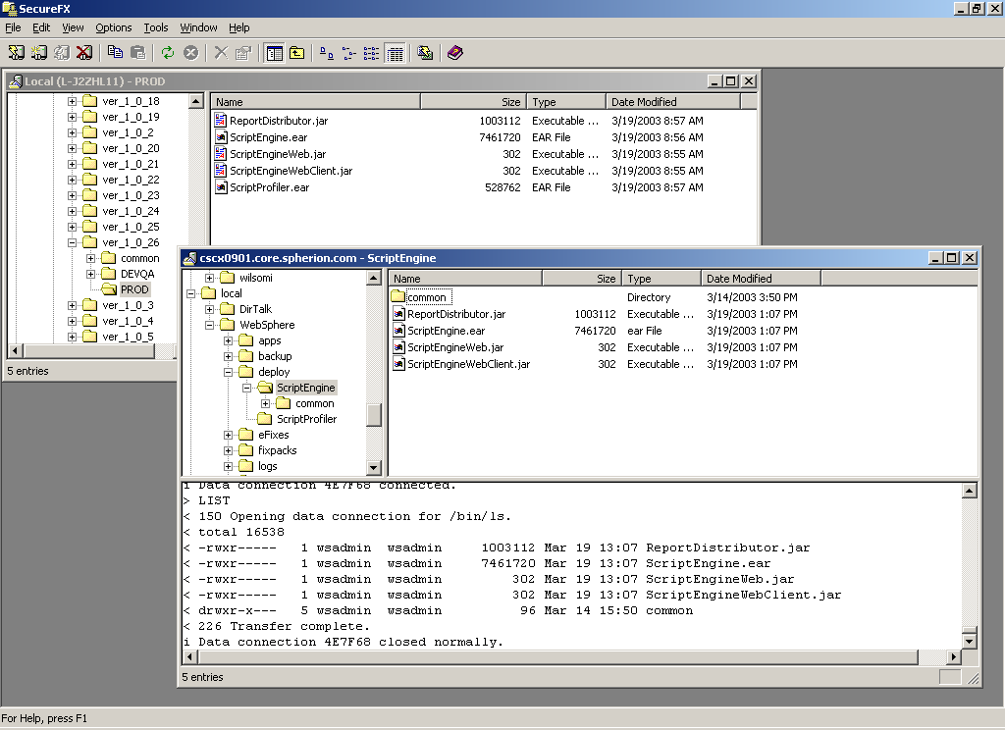

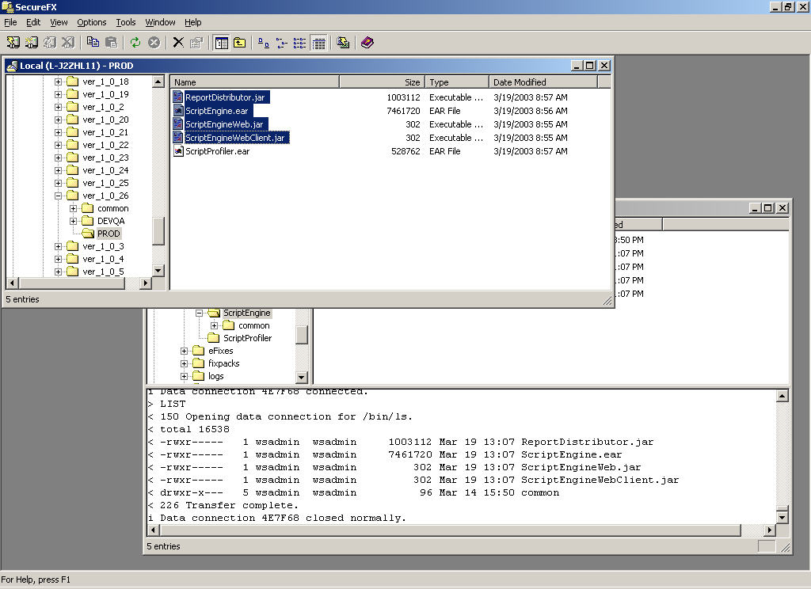

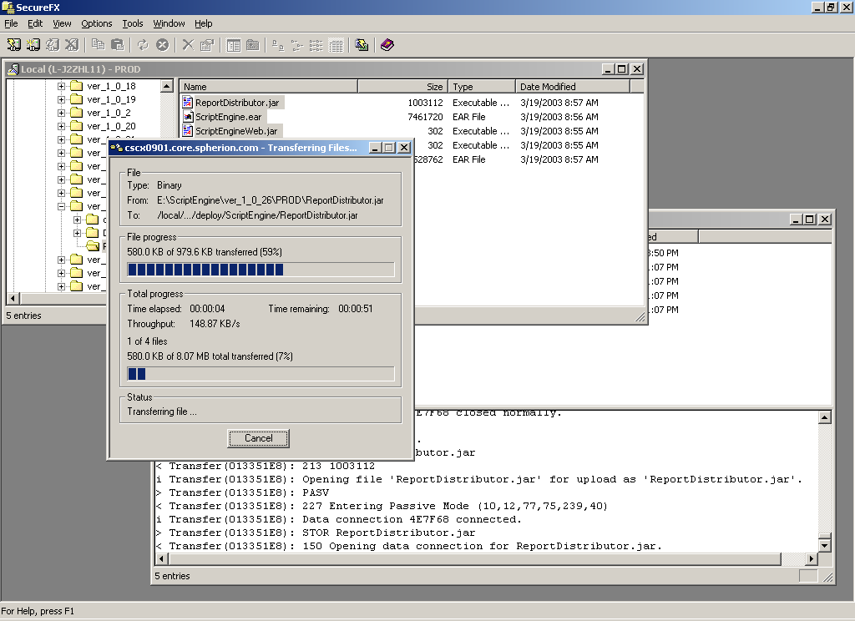

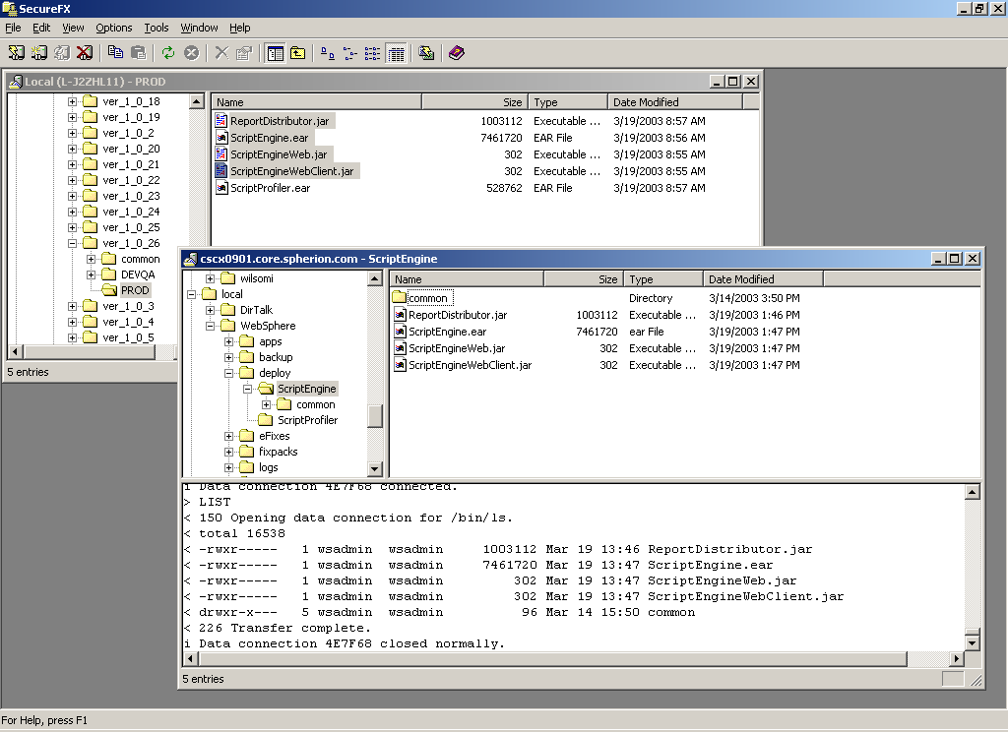

- Check date and time of ScriptEngine file(s) updates

[wsadmin @ cscx0901:/wshome/wsadmin]:> cd /local/WebSphere/deploy/ScriptEngine
[wsadmin @ cscx0901:/local/WebSphere/deploy/ScriptEngine]:> ls –al total 16542
drwxr-x--- 3 wsadmin wsadmin 1024 Mar 19 12:49 .
drwxr-x--- 4 wsadmin wsadmin 1024 Mar 04 23:59 ..
-rwxr----- 1 wsadmin wsadmin 1003112 Mar 19 13:46 ReportDistributor.jar
-rwxr----- 1 wsadmin wsadmin 7461720 Mar 19 13:47 ScriptEngine.ear
-rwxr----- 1 wsadmin wsadmin 302 Mar 19 13:47 ScriptEngineWeb.jar
-rwxr----- 1 wsadmin wsadmin 302 Mar 19 13:47 ScriptEngineWebClient.jar
drwxr-x--- 5 wsadmin wsadmin 96 Mar 21 13:44 common
[wsadmin @ cscx0901:/local/WebSphere/deploy/ScriptEngine]:>

- ScriptProfiler file(s) updates

Place new ScriptProfiler.ear deployment file in /local/WebSphere/deploy/ScriptProfiler directory on IVR production server (cscx0901) shown below:

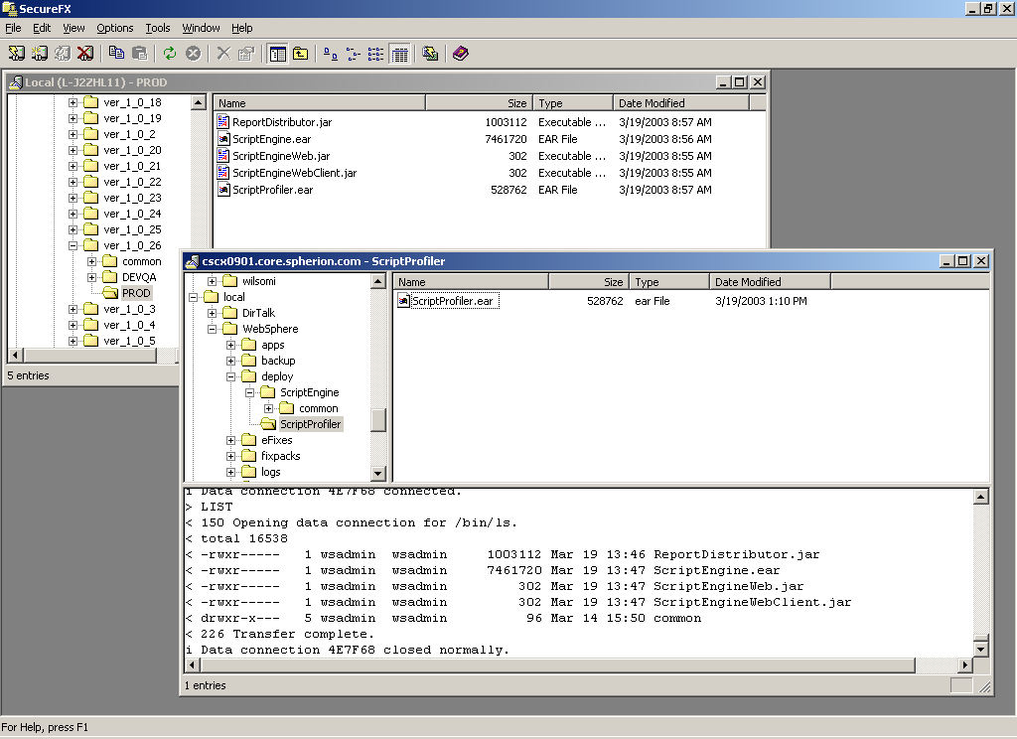

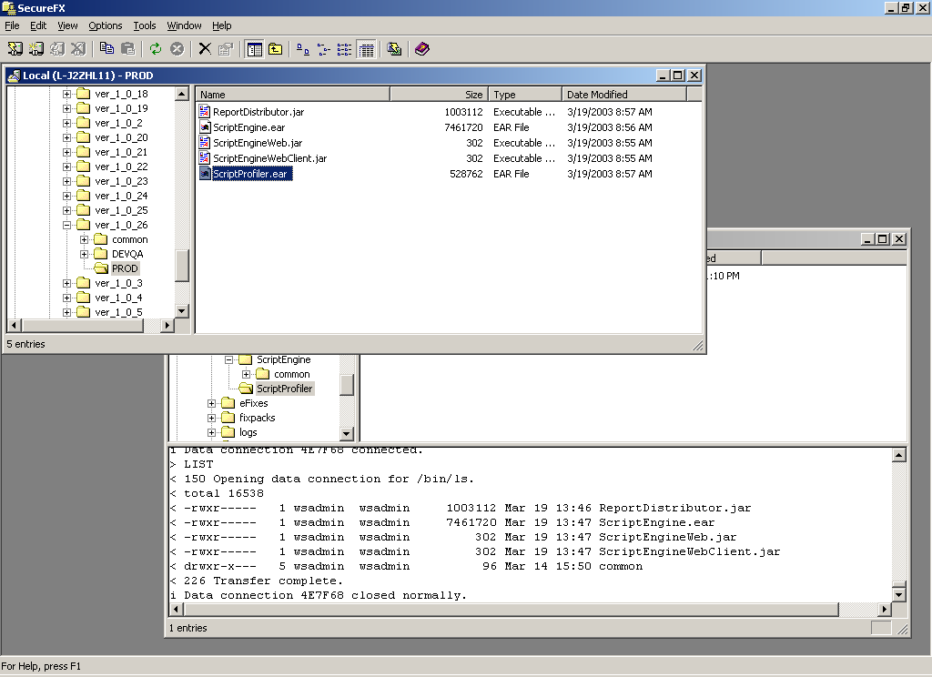

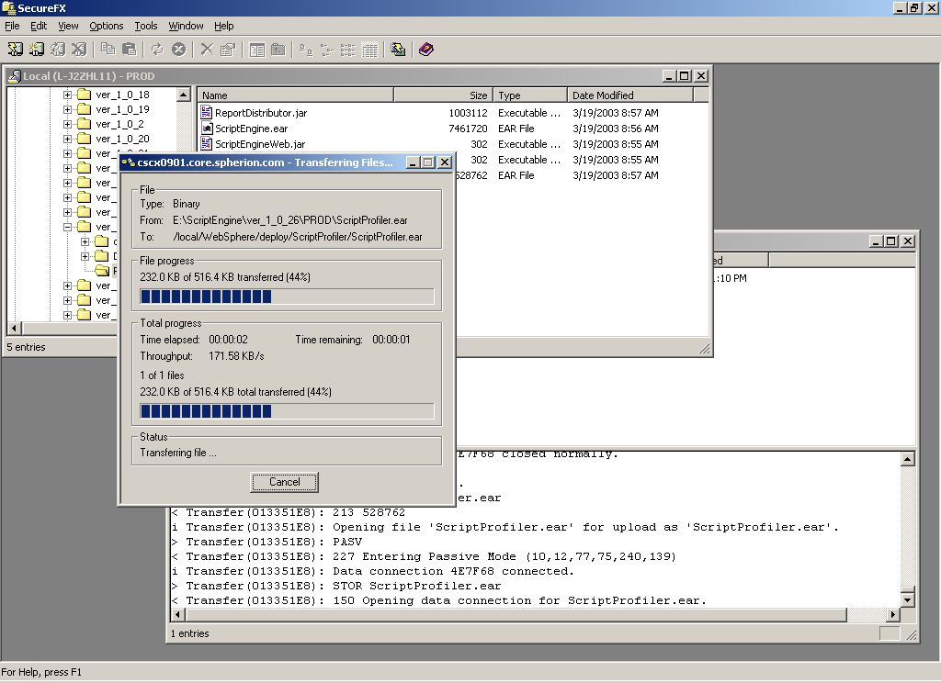

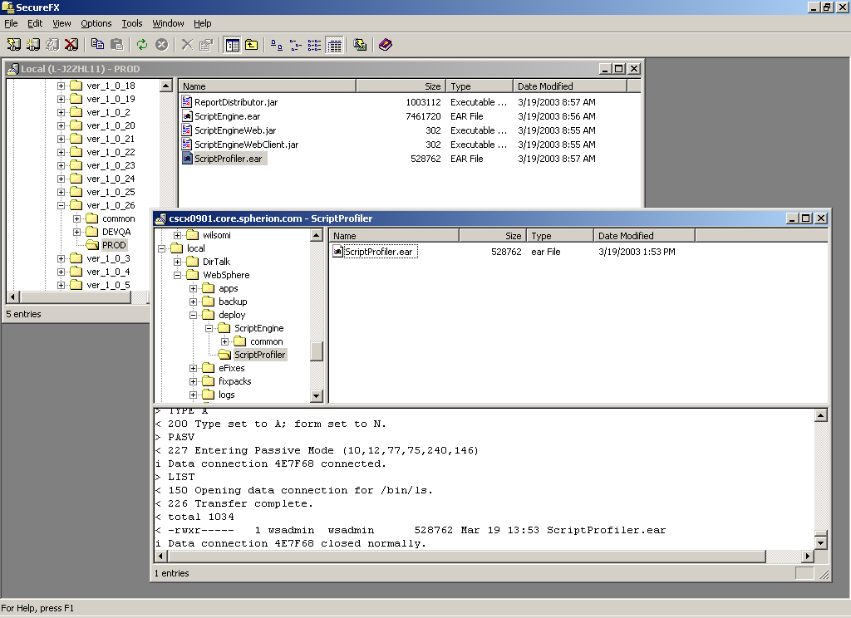

- Check date and time of ScriptProfiler file(s) updates

[wsadmin @ cscx0901:/wshome/wsadmin]:> cd /local/WebSphere/deploy/ScriptProfiler
[wsadmin @ cscx0901:/local/WebSphere/deploy/ScriptProfiler]:> ls –al
total 1036
drwxr----- 2 wsadmin wsadmin 96 Nov 11 13:55 .
drwxr-x--- 4 wsadmin wsadmin 1024 Mar 04 23:59 ..
-rwxr----- 1 wsadmin wsadmin 528762 Mar 19 13:53 ScriptProfiler.ear
[wsadmin @ cscx0901:/local/WebSphere/deploy/ScriptProfiler]:>

- Install new ScriptEngine deployment EAR file:

[wsadmin @ cscx0901:/wshome/wsadmin]:> installEntApp ScriptEngine

##################################################################
#
# Backup Existing Enterprise Application EAR
#
##################################################################

IBM WebSphere Application Server, Release 4.0
J2EE Application Expansion Tool, Version 1.0.1
Copyright IBM Corp., 1997-2001

Collapsing /opt/WebSphere/AppServer/installedApps/ScriptEngine.ear into /local/WebSphere/backup/EARs/200303150619.ScriptEngine.ear...

##################################################################
#
# FTP JAR file(s) to Web Server(s)
#
##################################################################

ScriptEngineWeb
ScriptEngineWeb
Pseudo-terminal will not be allocated because stdin is not a terminal.
Connecting to 12.16.9.188...
sftp> sftp> Uploading ScriptEngineWeb.jar to /inetweb/WebSiteRoot/ScriptEngine/ScriptEngineWeb/ScriptEngineWeb.jar

sftp> ScriptEngineWebClient
webivr
Pseudo-terminal will not be allocated because stdin is not a terminal.
Connecting to 12.16.9.188...
sftp> sftp> Uploading ScriptEngineWebClient.jar to /inetweb/WebSiteRoot/ScriptEngineClient/webivr/ScriptEngineWebClient.jar
sftp> ScriptEngineWeb
ScriptEngineWeb
Pseudo-terminal will not be allocated because stdin is not a terminal.
Connecting to 12.16.9.189...
sftp> sftp> Uploading ScriptEngineWeb.jar to /inetweb/WebSiteRoot/ScriptEngine/ScriptEngineWeb/ScriptEngineWeb.jar
sftp> ScriptEngineWebClient
webivr
Pseudo-terminal will not be allocated because stdin is not a terminal.
Connecting to 12.16.9.189...
sftp> sftp> Uploading ScriptEngineWebClient.jar to /inetweb/WebSiteRoot/ScriptEngineClient/webivr/ScriptEngineWebClient.jar
sftp>
##################################################################
#
# FTP EAR file to Remote App Server(s)
#
##################################################################

****** Stopping /EnterpriseApp:ScriptEngine/ ******

*** ScriptEngine Enterprise Application Status ***
*** {DesiredState} is actually {CurrentState} ***
/EnterpriseApp:ScriptEngine/ {DesiredState Stopped}

##################################################################
#
# Stop ScriptEngine ServerGroup
#
##################################################################

##################################################################
#
# ScriptEngine ServerGroup Status
#
##################################################################

/Node:cscx0901/ApplicationServer:ScriptEngineServer/ {CurrentState Stopped}

##################################################################
#
# Remove ScriptEngine Enterprise Application
#
##################################################################

##################################################################
#
# Install ScriptEngine Enterprise Application
#
##################################################################

##################################################################
#
# Remove ScriptEngine WebSphere Cache - Local Server
#
##################################################################

##################################################################
#
# Expand ScriptEngine EAR - Remote App Server(s)
# Remove ScriptEngine WebSphere Cache - Remote Server(s)
#
##################################################################

##################################################################
#
# Expand ScriptEngine JAR file(s) on Web Server(s)
#
##################################################################

Pseudo-terminal will not be allocated because stdin is not a terminal.
created: META-INF/
extracted: META-INF/MANIFEST.MF
Pseudo-terminal will not be allocated because stdin is not a terminal.
created: META-INF/
extracted: META-INF/MANIFEST.MF
Pseudo-terminal will not be allocated because stdin is not a terminal.
created: META-INF/
extracted: META-INF/MANIFEST.MF
Pseudo-terminal will not be allocated because stdin is not a terminal.
created: META-INF/
extracted: META-INF/MANIFEST.MF

##################################################################
#
# Start ScriptEngine ServerGroup
#
##################################################################

##################################################################
#
# ScriptEngine ServerGroup Status
#
##################################################################

/Node:cscx0901/ApplicationServer:ScriptEngineServer/ {CurrentState Running}

##########################################################
# #
# Backup Existing plugin-cfg.xml #
# #
##########################################################

##########################################################
# #
# Generate New plugin-cfg.xml #
# #
##########################################################

[3/15/03 6:24:40:611 EST] 29207c4 AEGeneratePlu A SRVE0098I: Generating plug-in configuration for this node
[3/15/03 6:25:01:440 EST] 29207c4 AEPluginCfg A ADGU1077I: Plugin regeneration completed successfully on node cscx0901.

##########################################################
# #
# Copy New plugin-cfg.xml to temporary file #
# #
##########################################################

##########################################################
# #
# Replace Node Names with IP Addresses in temporary file #
# #
##########################################################

##########################################################
# #
# Backup Existing plugin-cfg.xml on Web Server(s) #
# #
# Copy temporary plugin file from App Server to #
# plugin-cfg.xml on Web Server(s). #
# #
##########################################################

Connecting to 12.16.9.188...
sftp> sftp> Fetching /opt/WebSphere/AppServer/config/plugin-cfg.xml to plugin-cfg.xml
sftp> sftp> sftp> sftp> Uploading plugin-cfg.xml.200303150624 to /opt/WebSphere/AppServer/config/archive/plugin-cfg.xml.200303150624
sftp> sftp> sftp> Uploading plugin-cfg.xml to /opt/WebSphere/AppServer/config/plugin-cfg.xml
sftp> Connecting to 12.16.9.189...
sftp> sftp> Fetching /opt/WebSphere/AppServer/config/plugin-cfg.xml to plugin-cfg.xml
sftp> sftp> sftp> sftp> Uploading plugin-cfg.xml.200303150624 to /opt/WebSphere/AppServer/config/archive/plugin-cfg.xml.200303150624
sftp> sftp> sftp> Uploading plugin-cfg.xml to /opt/WebSphere/AppServer/config/plugin-cfg.xml
sftp>
##########################################################
#
# Output of this script can be viewed
# at /tmp/genPlugin.log
#
##########################################################

##########################################################
#
# Output of this script can be viewed
# at /tmp/installEntApp_ScriptEngine.log
#
##########################################################

[wsadmin @ cscx0901:/wshome/wsadmin]:>

- Install new ScriptProfiler deployment EAR file:

[wsadmin @ cscx0901:/wshome/wsadmin]:> installEntApp ScriptProfiler
cat: 0652-050 Cannot open /local/WebSphere/apps/ScriptProfiler/WebApp.txt.

##################################################################
#
# Backup Existing Enterprise Application EAR
#
##################################################################

IBM WebSphere Application Server, Release 4.0
J2EE Application Expansion Tool, Version 1.0.1
Copyright IBM Corp., 1997-2001

Collapsing /opt/WebSphere/AppServer/installedApps/ScriptProfiler.ear into /local/WebSphere/backup/EARs/200303150625.ScriptProfiler.ear...

##################################################################
#
# FTP JAR file(s) to Web Server(s)
#
##################################################################

cat: 0652-050 Cannot open /local/WebSphere/apps/ScriptProfiler/WebApp.txt.
cat: 0652-050 Cannot open /local/WebSphere/apps/ScriptProfiler/WebApp.txt.

##################################################################
#
# FTP EAR file to Remote App Server(s)
#
##################################################################

****** Stopping /EnterpriseApp:ScriptProfiler/ ******

*** ScriptProfiler Enterprise Application Status ***
*** {DesiredState} is actually {CurrentState} ***
/EnterpriseApp:ScriptProfiler/ {DesiredState Stopped}

##################################################################
#
# Stop ScriptProfiler ServerGroup
#
##################################################################

##################################################################
#
# ScriptProfiler ServerGroup Status
#
##################################################################

/Node:cscx0901/ApplicationServer:ScriptProfilerServer/ {CurrentState Stopped}

##################################################################
#
# Remove ScriptProfiler Enterprise Application
#
##################################################################

##################################################################
#
# Install ScriptProfiler Enterprise Application
#
##################################################################

##################################################################
#
# Remove ScriptProfiler WebSphere Cache - Local Server
#
##################################################################

rm: /opt/WebSphere/AppServer/temp/cscx0901/ScriptProfilerServer/*: A file or directory in the path name does not exist.

##################################################################
#
# Expand ScriptProfiler EAR - Remote App Server(s)
# Remove ScriptProfiler WebSphere Cache - Remote Server(s)
#
##################################################################

##################################################################
#
# Expand ScriptProfiler JAR file(s) on Web Server(s)
#
##################################################################

cat: 0652-050 Cannot open /local/WebSphere/apps/ScriptProfiler/WebApp.txt.
cat: 0652-050 Cannot open /local/WebSphere/apps/ScriptProfiler/WebApp.txt.

##################################################################
#
# Start ScriptProfiler ServerGroup
#
##################################################################

##################################################################
#
# ScriptProfiler ServerGroup Status
#
##################################################################

/Node:cscx0901/ApplicationServer:ScriptProfilerServer/ {CurrentState Running}

##########################################################
# #
# Backup Existing plugin-cfg.xml #
# #
##########################################################

##########################################################
# #
# Generate New plugin-cfg.xml #
# #
##########################################################

[3/15/03 6:30:18:122 EST] 292077d AEGeneratePlu A SRVE0098I: Generating plug-in configuration for this node
[3/15/03 6:30:37:414 EST] 292077d AEPluginCfg A ADGU1077I: Plugin regeneration completed successfully on node cscx0901.

##########################################################
# #
# Copy New plugin-cfg.xml to temporary file #
# #
##########################################################

##########################################################
# #
# Replace Node Names with IP Addresses in temporary file #
# #
##########################################################

##########################################################
# #
# Backup Existing plugin-cfg.xml on Web Server(s) #
# #
# Copy temporary plugin file from App Server to #
# plugin-cfg.xml on Web Server(s). #
# #
##########################################################

Connecting to 12.16.9.188...
sftp> sftp> Fetching /opt/WebSphere/AppServer/config/plugin-cfg.xml to plugin-cfg.xml
sftp> sftp> sftp> sftp> Uploading plugin-cfg.xml.200303150630 to /opt/WebSphere/AppServer/config/archive/plugin-cfg.xml.200303150630
sftp> sftp> sftp> Uploading plugin-cfg.xml to /opt/WebSphere/AppServer/config/plugin-cfg.xml
sftp> Connecting to 12.16.9.189...
sftp> sftp> Fetching /opt/WebSphere/AppServer/config/plugin-cfg.xml to plugin-cfg.xml
sftp> sftp> sftp> sftp> Uploading plugin-cfg.xml.200303150630 to /opt/WebSphere/AppServer/config/archive/plugin-cfg.xml.200303150630
sftp> sftp> sftp> Uploading plugin-cfg.xml to /opt/WebSphere/AppServer/config/plugin-cfg.xml
sftp>

##########################################################
#
# Output of this script can be viewed
# at /tmp/genPlugin.log
#
##########################################################

##########################################################
#
# Output of this script can be viewed
# at /tmp/installEntApp_ScriptProfiler.log
#
##########################################################

[wsadmin @ cscx0901:/wshome/wsadmin]:>

- Verify all WebSphere processes are running:

[wsadmin @ cscx0901:/wshome/wsadmin]:> showwas.sh
java process status as at 2003/03/15-06:31:36

** WebSphere Nanny **
USER PID PPID ST TIME VSZ
wsadmin 52064 80382 A 00:00:07 60936

** WebSphere Admin Server **
USER PID PPID ST TIME VSZ
wsadmin 88126 52064 A 00:01:21 121048

** WebSphere Application Servers **
wsadmin 86186 88126 ScriptProfilerServer
wsadmin 100594 88126 ScriptEngineServer

[wsadmin @ cscx0901:/wshome/wsadmin]:>

DirectTalk Beans Java Application Deployment

NOTE: This should be done from office during normal business hours and not over remote VPN connection if possible before performing maintenance work after hours. This could take more than 30 minutes over VPN connection.

- Locate new remote.jar, XYZ.jar and ScriptEngine.jar deployment JAR file(s)

The deployment EAR file(s) are located in the following \\uscscsvc2\wasdeploy$ network share:

Inside the DirTalk folder shown below:

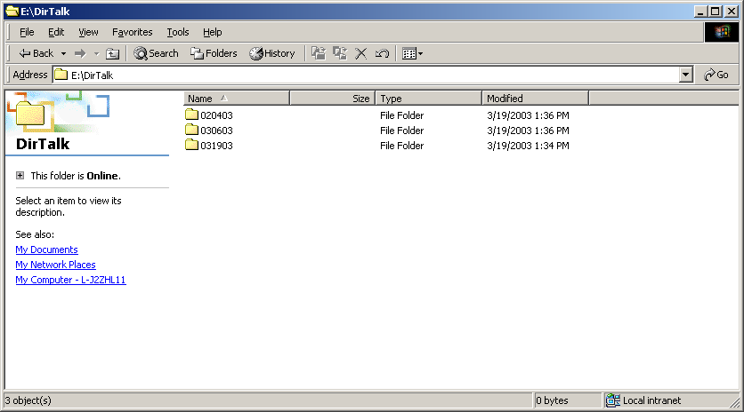

Choose appropriate deployment version (031903 as an example) shown below:

NOTE: These files currently come directly from development via e-mail as an attachment as they are not using Rational for versioned labels. Therefore, we need to create new dated folders for new deployment files as we continue to receive them via email attachment until development starts using Rational for versioned labels.

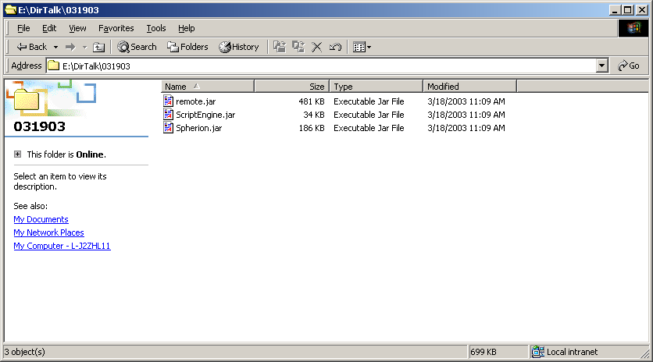

- DTBE (DirectTalk Beans Environment) Java application update(s)

NOTE: We currently ftp the appropriate DTBE java application deployment files to the IVR production system using our SecureFX tool as dtuser.

- FTP updates for remote.jar, ScriptEngine.jar and XYZ.jar

NOTE: There may be one or more deployment file(s) for any given maintenance window. Thus, we might only be deploying one or more file(s) during a scheduled maintenance window as directed by development.

Place remote.jar, ScriptEngine.jar and XYZ.jar deployment file(s) in /local/DirTalk/deploy directory on IVR production server (cscx0901) shown below:

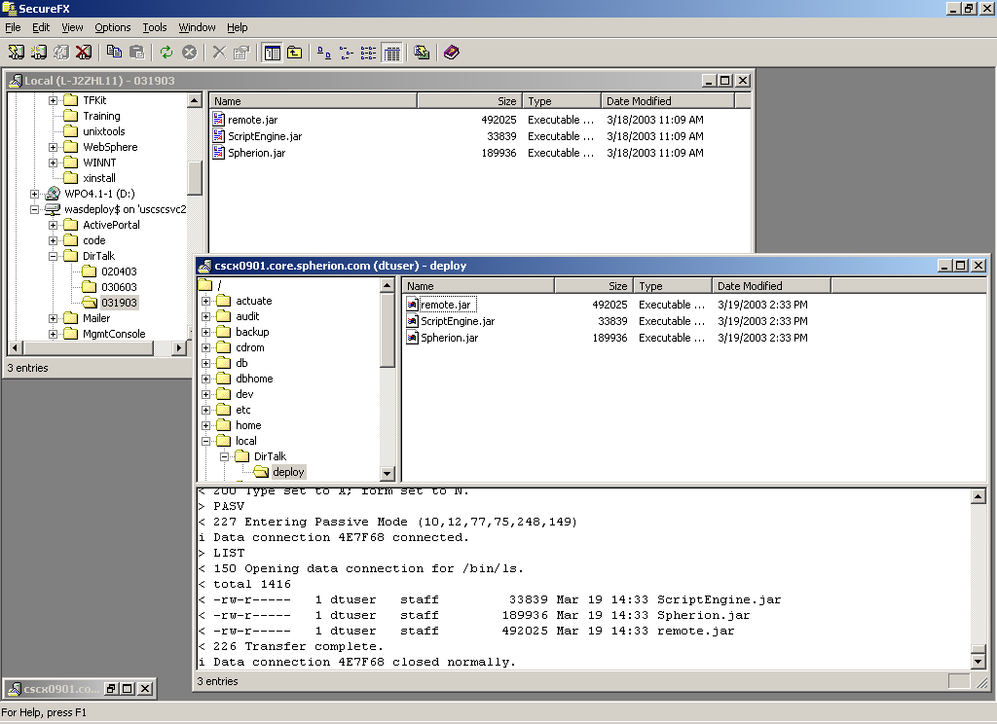

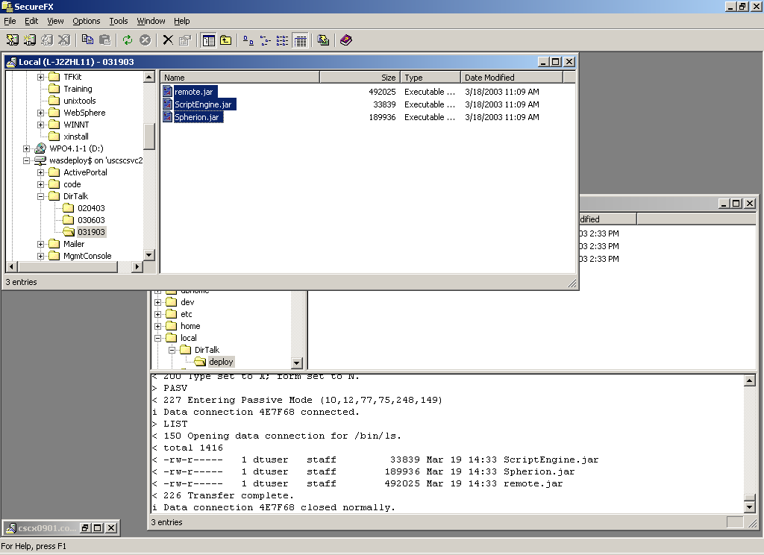

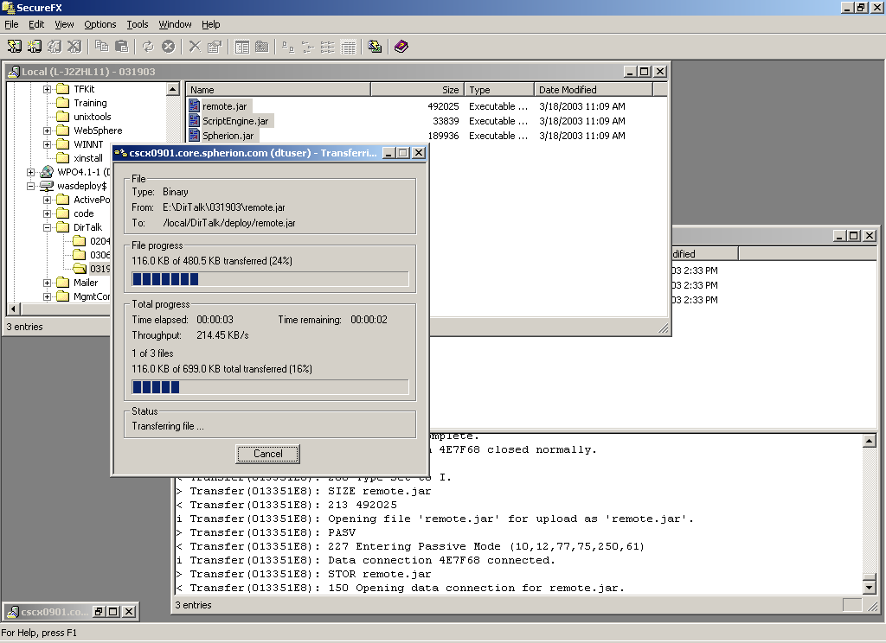

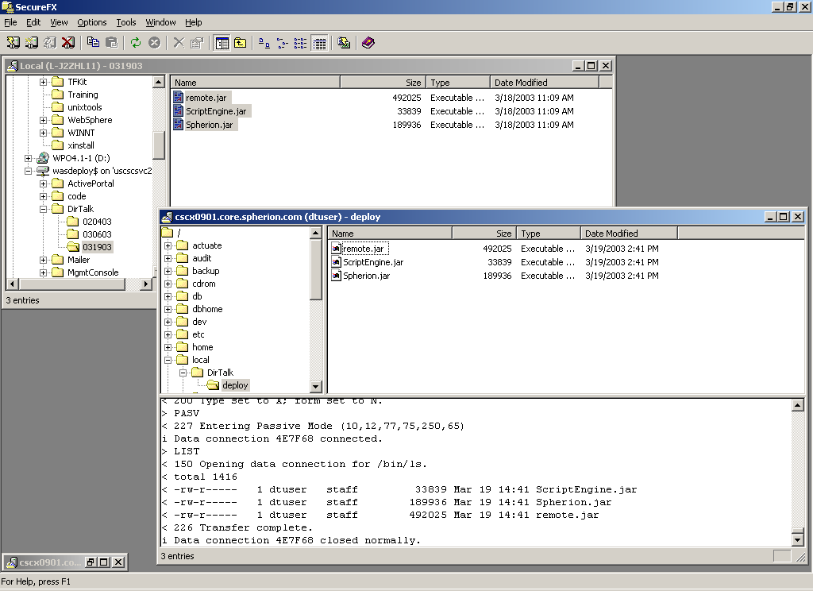

- Check date and time of ftp updates.

[dtuser@cscx0901:/home/dtuser]:> cd /local/DirTalk/deploy
[dtuser@cscx0901:/local/DirTalk/deploy]:> ls -al
total 1808
drwxr-xr-x 2 dtuser staff 512 Mar 20 16:16 .
drwxr-xr-x 3 dtuser staff 512 Mar 19 14:30 ..
-rw-r----- 1 dtuser staff 33839 Mar 19 14:41 ScriptEngine.jar
-rw-r----- 1 dtuser staff 189831 Mar 20 16:21 XYZ.jar
-rw-r----- 1 dtuser staff 492025 Mar 19 14:41 remote.jar
[dtuser@cscx0901:/local/DirTalk/deploy]:>

- Install new remote.jar deployment JAR file.

[dtuser@cscx0901:/home/dtuser]:> cd /local/DirTalk/deploy
[dtuser@cscx0901:/local/DirTalk/deploy]:> cp ./remote.jar /home/dtuser/system/record/remote.jar
[dtuser@cscx0901:/local/DirTalk/deploy]:>

- Verify new remote.jar deployment JAR file copy was successful

[dtuser@cscx0901:/local/DirTalk/deploy]:> cd /home/dtuser/system/record
[dtuser@cscx0901:/home/dtuser/system/record]:> ls -al
total 1020
drwxr-s--- 4 dtuser dtgrp 1024 Mar 19 13:39 .
drwxr-sr-x 11 dtuser dtgrp 1024 Mar 17 15:01 ..
drwxr-sr-x 2 dtuser dtgrp 96 Jan 05 12:15 META-INF
drwxr-sr-x 3 dtuser dtgrp 96 Jan 06 18:57 com
-rw-r--r-- 1 dtuser dtgrp 13620 Jan 06 18:47 rem1.txt
-rw-r--r-- 1 dtuser dtgrp 12428 Jan 06 18:48 rem2.txt
-rw-r----- 1 dtuser dtgrp 492025 Mar 06 17:58 remote.jar
[dtuser@cscx0901:/home/dtuser/system/record]:>

- Install new ScriptEngine.jar deployment JAR file

[dtuser@cscx0901:/home/dtuser]:> cd /local/DirTalk/deploy
[dtuser@cscx0901:/local/DirTalk/deploy]:> cp ./ScriptEngine.jar /home/dtuser/system/lib/ScriptEngine.jar
[dtuser@cscx0901:/home/dtuser]:>

- Verify new ScriptEngine.jar deployment JAR file copy was successful

[dtuser@cscx0901:/local/DirTalk/deploy]:> cd /home/dtuser/system/lib
[dtuser@cscx0901:/home/dtuser/system/lib]:> ls -al
total 17502
drwxr-s--- 2 dtuser dtgrp 1024 Mar 19 13:42 .
drwxr-sr-x 11 dtuser dtgrp 1024 Mar 17 15:01 ..
-rw-r----- 1 dtuser dtgrp 37225 Nov 07 09:18 CAdmin.jar
-rw-r----- 1 dtuser dtgrp 20158 Nov 07 09:18 Inapp.jar
-rw-r----- 1 dtuser dtgrp 33839 Mar 06 17:57 ScriptEngine.jar
-rw-r----- 1 dtuser dtgrp 189936 Mar 06 17:57 XYZ.jar
-rw-r----- 1 dtuser dtgrp 5750 Nov 07 09:18 TestApp.jar
-rw-r----- 1 dtuser dtgrp 5573 Nov 07 09:18 bootstrap.jar
-rw-r----- 1 dtuser dtgrp 27747 Nov 07 09:18 ibmivrx.jar
-rw-r----- 1 dtuser dtgrp 32033 Nov 07 09:18 ivjejb35.jar
-rw-r----- 1 dtuser dtgrp 4467626 Nov 07 09:18 iwsorb.jar
-rw-r----- 1 dtuser dtgrp 329096 Nov 07 09:18 j2ee.jar
-rw-r----- 1 dtuser dtgrp 2234866 Nov 07 09:18 j2eetools.jar
-rw-r----- 1 dtuser dtgrp 374291 Nov 07 09:18 ns.jar
-rw-r----- 1 dtuser dtgrp 143165 Nov 07 09:18 ras.jar
-rw-r----- 1 dtuser dtgrp 296640 Nov 07 09:18 ujc.jar
-rw-r----- 1 dtuser dtgrp 638551 Nov 07 09:18 utils.jar
-rw-r----- 1 dtuser dtgrp 114616 Nov 07 09:18 websphere.jar
[dtuser@cscx0901:/home/dtuser/system/lib]:>

- Install new XYZ.jar deployment JAR file.

[dtuser@cscx0901:/home/dtuser]:> cd /local/DirTalk/deploy
[dtuser@cscx0901:/local/DirTalk/deploy]:> cp ./XYZ.jar /home/dtuser/system/lib/XYZ.jar
[dtuser@cscx0901:/home/dtuser]:>

- Verify new XYZ.jar deployment JAR file copy was successful

[dtuser@cscx0901:/local/DirTalk/deploy]:> cd /home/dtuser/system/lib
[dtuser@cscx0901:/home/dtuser/system/lib]:> ls -al
total 17502
drwxr-s--- 2 dtuser dtgrp 1024 Mar 19 13:42 .
drwxr-sr-x 11 dtuser dtgrp 1024 Mar 17 15:01 ..
-rw-r----- 1 dtuser dtgrp 37225 Nov 07 09:18 CAdmin.jar
-rw-r----- 1 dtuser dtgrp 20158 Nov 07 09:18 Inapp.jar
-rw-r----- 1 dtuser dtgrp 33839 Mar 06 17:57 ScriptEngine.jar
-rw-r----- 1 dtuser dtgrp 189936 Mar 06 17:57 XYZ.jar
-rw-r----- 1 dtuser dtgrp 5750 Nov 07 09:18 TestApp.jar
-rw-r----- 1 dtuser dtgrp 5573 Nov 07 09:18 bootstrap.jar
-rw-r----- 1 dtuser dtgrp 27747 Nov 07 09:18 ibmivrx.jar
-rw-r----- 1 dtuser dtgrp 32033 Nov 07 09:18 ivjejb35.jar
-rw-r----- 1 dtuser dtgrp 4467626 Nov 07 09:18 iwsorb.jar
-rw-r----- 1 dtuser dtgrp 329096 Nov 07 09:18 j2ee.jar
-rw-r----- 1 dtuser dtgrp 2234866 Nov 07 09:18 j2eetools.jar
-rw-r----- 1 dtuser dtgrp 374291 Nov 07 09:18 ns.jar
-rw-r----- 1 dtuser dtgrp 143165 Nov 07 09:18 ras.jar
-rw-r----- 1 dtuser dtgrp 296640 Nov 07 09:18 ujc.jar
-rw-r----- 1 dtuser dtgrp 638551 Nov 07 09:18 utils.jar
-rw-r----- 1 dtuser dtgrp 114616 Nov 07 09:18 websphere.jar
[dtuser@cscx0901:/home/dtuser/system/lib]:>

Additional Potential Maintenance Tasks
NOTE: These maintenance tasks are not performed on a regular basis and should only be done when requested by development group. We can update this section for each new potential maintenance task as requested in the future.

- Delete all HTML files in the /home/dtuser/system/common/profiles directory

[wsadmin @ cscx0901:/wshome/wsadmin]:> cd /home/dtuser/system/common/profiles
[wsadmin @ cscx0901:/home/dtuser/system/common/profiles]:> ls -al
total 1578
drwxrws--- 4 wsadmin staff 24576 Mar 21 16:18 .
drwxrws--- 5 dtuser staff 96 Mar 17 21:05 ..
-rw-r----- 1 wsadmin staff 8815 Mar 20 09:52 CandidateProfile.xsd
-rw-r--r-- 1 wsadmin staff 5746 Mar 21 11:01 Candidate_50001637.html
-rw-r--r-- 1 wsadmin staff 6280 Mar 21 14:54 Candidate_50002406.html
-rw-r--r-- 1 wsadmin staff 5049 Mar 05 09:23 Candidate_50002522.html
-rw-r--r-- 1 wsadmin staff 5936 Mar 05 09:10 Candidate_50002567.html
-rw-r--r-- 1 wsadmin staff 5296 Mar 06 16:43 Candidate_50003164.html
-rw-r--r-- 1 wsadmin staff 5121 Mar 20 22:36 Candidate_50003625.html
-rw-r--r-- 1 wsadmin staff 6202 Mar 20 22:39 Candidate_50003757.html
-rw-r--r-- 1 wsadmin staff 5535 Mar 14 16:00 Candidate_50005561.html
-rw-r--r-- 1 wsadmin staff 6322 Mar 18 15:49 Candidate_50006625.html
-rw-r--r-- 1 wsadmin staff 6260 Mar 18 15:39 Candidate_50006626.html
-rw-r--r-- 1 wsadmin staff 3595 Mar 18 18:21 Candidate_50006838.html
-rw-r--r-- 1 wsadmin staff 5985 Mar 19 00:11 Candidate_50006968.html
-rw-r--r-- 1 wsadmin staff 8283 Mar 19 09:47 Candidate_50006994.html
-rw-r--r-- 1 wsadmin staff 6299 Mar 19 19:24 Candidate_50007297.html
-rw-r--r-- 1 wsadmin staff 5976 Mar 20 11:32 Candidate_50007338.html
-rw-r--r-- 1 wsadmin staff 5968 Mar 20 01:27 Candidate_50007342.html
-rw-r--r-- 1 wsadmin staff 5280 Mar 20 11:31 Candidate_50007356.html
-rw-r--r-- 1 wsadmin staff 5091 Mar 20 11:30 Candidate_50007357.html
-rw-r--r-- 1 wsadmin staff 5715 Mar 20 11:31 Candidate_50007375.html
-rw-r--r-- 1 wsadmin staff 6121 Mar 20 11:29 Candidate_50007394.html
-rw-r--r-- 1 wsadmin staff 6343 Mar 20 11:59 Candidate_50007398.html
-rw-r--r-- 1 wsadmin staff 7118 Mar 20 15:23 Candidate_50007400.html
-rw-r--r-- 1 wsadmin staff 6439 Mar 20 15:28 Candidate_50007403.html
-rw-r--r-- 1 wsadmin staff 6741 Mar 20 12:25 Candidate_50007405.html
-rw-r--r-- 1 wsadmin staff 5514 Mar 20 15:23 Candidate_50007406.html
-rw-r--r-- 1 wsadmin staff 6448 Mar 20 15:28 Candidate_50007418.html
-rw-r--r-- 1 wsadmin staff 5343 Mar 20 15:24 Candidate_50007424.html
-rw-r--r-- 1 wsadmin staff 6577 Mar 20 13:28 Candidate_50007427.html
-rw-r--r-- 1 wsadmin staff 5158 Mar 20 15:25 Candidate_50007428.html
-rw-r--r-- 1 wsadmin staff 5925 Mar 20 15:25 Candidate_50007430.html
-rw-r--r-- 1 wsadmin staff 5123 Mar 20 15:26 Candidate_50007461.html
-rw-r--r-- 1 wsadmin staff 7492 Mar 20 15:28 Candidate_50007464.html
-rw-r--r-- 1 wsadmin staff 5727 Mar 20 15:27 Candidate_50007473.html
-rw-r--r-- 1 wsadmin staff 6722 Mar 20 15:28 Candidate_50007483.html
-rw-r--r-- 1 wsadmin staff 6047 Mar 20 15:56 Candidate_50007491.html
-rw-r--r-- 1 wsadmin staff 5853 Mar 20 17:13 Candidate_50007503.html
-rw-r--r-- 1 wsadmin staff 4939 Mar 20 17:14 Candidate_50007510.html
-rw-r--r-- 1 wsadmin staff 5099 Mar 20 17:14 Candidate_50007513.html
-rw-r--r-- 1 wsadmin staff 3138 Mar 20 17:10 Candidate_50007521.html
-rw-r--r-- 1 wsadmin staff 6460 Mar 20 17:28 Candidate_50007528.html
-rw-r--r-- 1 wsadmin staff 4815 Mar 20 17:28 Candidate_50007529.html
-rw-r--r-- 1 wsadmin staff 5101 Mar 20 17:40 Candidate_50007537.html
-rw-r--r-- 1 wsadmin staff 7031 Mar 20 18:34 Candidate_50007539.html
-rw-r--r-- 1 wsadmin staff 5470 Mar 20 18:34 Candidate_50007540.html
-rw-r--r-- 1 wsadmin staff 5421 Mar 20 20:47 Candidate_50007571.html
-rw-r--r-- 1 wsadmin staff 6904 Mar 20 20:48 Candidate_50007575.html
-rw-r--r-- 1 wsadmin staff 6847 Mar 20 20:48 Candidate_50007579.html
-rw-r--r-- 1 wsadmin staff 6842 Mar 20 20:49 Candidate_50007582.html
-rw-r--r-- 1 wsadmin staff 5307 Mar 20 20:49 Candidate_50007584.html
-rw-r--r-- 1 wsadmin staff 5502 Mar 20 21:14 Candidate_50007588.html
-rw-r--r-- 1 wsadmin staff 5381 Mar 21 00:27 Candidate_50007592.html
-rw-r--r-- 1 wsadmin staff 5114 Mar 21 00:27 Candidate_50007593.html
-rw-r--r-- 1 wsadmin staff 6631 Mar 21 00:25 Candidate_50007600.html
-rw-r--r-- 1 wsadmin staff 7184 Mar 21 00:25 Candidate_50007605.html
-rw-r--r-- 1 wsadmin staff 6435 Mar 21 00:26 Candidate_50007614.html
-rw-r--r-- 1 wsadmin staff 6838 Mar 21 00:26 Candidate_50007618.html
-rw-r--r-- 1 wsadmin staff 5983 Mar 21 00:29 Candidate_50007621.html
-rw-r--r-- 1 wsadmin staff 5950 Mar 20 23:39 Candidate_50007626.html
-rw-r--r-- 1 wsadmin staff 5417 Mar 21 00:29 Candidate_50007629.html
-rw-r--r-- 1 wsadmin staff 6080 Mar 20 23:59 Candidate_50007631.html
-rw-r--r-- 1 wsadmin staff 5317 Mar 21 00:28 Candidate_50007632.html
-rw-r--r-- 1 wsadmin staff 3744 Mar 21 00:45 Candidate_50007649.html
-rw-r--r-- 1 wsadmin staff 3925 Mar 21 00:59 Candidate_50007651.html
-rw-r--r-- 1 wsadmin staff 4939 Mar 21 10:28 Candidate_50007654.html
-rw-r--r-- 1 wsadmin staff 6317 Mar 21 10:28 Candidate_50007663.html
-rw-r--r-- 1 wsadmin staff 0 Mar 21 13:35 Candidate_50007664.html
-rw-r--r-- 1 wsadmin staff 5112 Mar 21 11:44 Candidate_50007698.html
-rw-r--r-- 1 wsadmin staff 8017 Mar 21 11:04 Candidate_50007704.html
-rw-r--r-- 1 wsadmin staff 5581 Mar 21 11:06 Candidate_50007705.html
-rw-r--r-- 1 wsadmin staff 5752 Mar 21 12:32 Candidate_50007736.html
-rw-r--r-- 1 wsadmin staff 5533 Mar 21 13:10 Candidate_50007737.html
-rw-r--r-- 1 wsadmin staff 2671 Mar 21 12:46 Candidate_50007754.html
-rw-r--r-- 1 wsadmin staff 5494 Mar 21 13:33 Candidate_50007769.html
-rw-r--r-- 1 wsadmin staff 3478 Mar 21 13:54 Candidate_50007785.html
-rw-r--r-- 1 wsadmin staff 5750 Mar 21 15:12 Candidate_50007787.html
-rw-r--r-- 1 wsadmin staff 11810 Mar 21 13:57 Candidate_50007789.html
-rw-r--r-- 1 wsadmin staff 3820 Mar 21 14:01 Candidate_50007794.html
-rw-r--r-- 1 wsadmin staff 3823 Mar 21 15:09 Candidate_50007797.html
-rw-r--r-- 1 wsadmin staff 3956 Mar 21 15:10 Candidate_50007801.html
-rw-r--r-- 1 wsadmin staff 7030 Mar 21 15:13 Candidate_50007802.html
-rw-r--r-- 1 wsadmin staff 3848 Mar 21 15:10 Candidate_50007808.html
-rw-r--r-- 1 wsadmin staff 6231 Mar 21 15:11 Candidate_50007817.html
-rw-r--r-- 1 wsadmin staff 6701 Mar 21 15:11 Candidate_50007827.html
-rw-r--r-- 1 wsadmin staff 7455 Mar 21 15:00 Candidate_50007832.html
-rw-r--r-- 1 wsadmin staff 8430 Mar 21 15:23 Candidate_50007836.html
-rw-r--r-- 1 wsadmin staff 5722 Mar 21 16:03 Candidate_50007840.html
-rw-r--r-- 1 wsadmin staff 2732 Mar 21 15:56 Candidate_50007855.html
-rw-r--r-- 1 wsadmin staff 5681 Mar 21 16:10 Candidate_50007860.html
-rw-r--r-- 1 wsadmin staff 5548 Mar 21 16:18 Candidate_50007863.html
drwxr-s--- 2 wsadmin staff 212992 Mar 21 16:29 xml
drwxr-s--- 3 wsadmin staff 1024 Mar 14 09:51 xsl
[wsadmin @ cscx0901:/home/dtuser/system/common/profiles]:>rm *.html
[wsadmin @ cscx0901:/home/dtuser/system/common/profiles]:>ls –al
total 462
drwxr-xr-x 4 wsadmin wsadmin 4096 Mar 21 16:42 .
drwxr-xr-x 4 wsadmin wsadmin 1024 Mar 21 16:33 ..
-rw-r----- 1 wsadmin wsadmin 8815 Mar 21 16:34 CandidateProfile.xsd
drwxr-s--- 2 wsadmin wsadmin 212992 Mar 21 16:35 xml
drwxr-s--- 3 wsadmin wsadmin 1024 Mar 21 16:35 xsl
[wsadmin @ cscx0901:/home/dtuser/system/common/profiles]:>

DBA Notification Database Updates Are Complete
NOTE: We have currently been working with Wadsworth S. Rankine for IVR production database support. Also, we must wait here until the DBA group is finished before we enable end-user access and perform post-maintenance test procedures.

- Wait for DBA group to inform us the database update(s) are complete.
This has been done via telephone with Wadsworth (cellular) so far!

http://intranet.XYZ.com
XYZ

NO
PHOTO
Wadsworth S. Riley

Enable End-User Access

- Start Web servers (uscscweb13 and uscscweb14) to enable the end-user Web access.

NOTE: Perform this task as root user.

[root@uscscweb13 root]# service ibmhttpd start
/etc/init.d/ibmhttpd start: httpd started
[root@uscscweb13 root]#

[root@uscscweb14 root]# service ibmhttpd start
/etc/init.d/ibmhttpd start: httpd started
[root@uscscweb14 root]#

- Check to see if Web servers (uscscweb13 and uscscweb14) are running.

[root@uscscweb13 root]# ps -ef | grep -i http
root 29732 1 44 16:36 ? 00:00:02 /opt/IBMHTTPServer/bin/httpd
nobody 29735 29732 0 16:36 ? 00:00:00 /opt/IBMHTTPServer/bin/sidd 0
nobody 29736 29732 4 16:36 ? 00:00:00 /opt/IBMHTTPServer/bin/httpd
nobody 29737 29732 0 16:36 ? 00:00:00 /opt/IBMHTTPServer/bin/httpd
nobody 29738 29732 0 16:36 ? 00:00:00 /opt/IBMHTTPServer/bin/httpd
nobody 29739 29732 1 16:36 ? 00:00:00 /opt/IBMHTTPServer/bin/httpd
nobody 29740 29732 0 16:36 ? 00:00:00 /opt/IBMHTTPServer/bin/httpd
root 29744 29675 0 16:36 pts/0 00:00:00 grep -i http
[root@uscscweb13 root]#

[root@uscscweb14 root]# ps -ef | grep -i http
root 12384 1 43 16:37 ? 00:00:03 /opt/IBMHTTPServer/bin/httpd
nobody 12387 12384 1 16:37 ? 00:00:00 /opt/IBMHTTPServer/bin/sidd 0
nobody 12388 12384 1 16:37 ? 00:00:00 /opt/IBMHTTPServer/bin/httpd
nobody 12389 12384 7 16:37 ? 00:00:00 /opt/IBMHTTPServer/bin/httpd
nobody 12390 12384 1 16:37 ? 00:00:00 /opt/IBMHTTPServer/bin/httpd
nobody 12391 12384 1 16:37 ? 00:00:00 /opt/IBMHTTPServer/bin/httpd
nobody 12392 12384 1 16:37 ? 00:00:00 /opt/IBMHTTPServer/bin/httpd
root 12396 12327 0 16:37 pts/0 00:00:00 grep -i http
[root@uscscweb14 root]#

- Start DirectTalk Beans environment to enable end-user telephony access

NOTE: Perform this task as dtuser

[dtuser@cscx0901:/home/dtuser]:> dtjstart
Running the PlexManager to start the LocalHost ...
2003.02.07 15:54:43 I DTJ3015 Starting voice response node Node1 at host LocalHost.
2003.02.07 15:54:46 I DTJ3030 Starting applications for node Node1 at host LocalHost.
2003.02.07 15:54:47 I DTJ3019 Application menu was started on node Node1 at host LocalHost.
2003.02.07 15:54:47 I DTJ3016 Voice response node Node1 at host LocalHost has started.
2003.02.07 15:54:48 I DTJ3019 Application DnisDriver was started on node Node1 at host LocalHost.
2003.02.07 15:54:48 I DTJ3019 Application DnisDriver was started on node Node1 at host LocalHost.
2003.02.07 15:54:48 I DTJ3019 Application DnisDriver was started on node Node1 at host LocalHost.
2003.02.07 15:54:48 I DTJ3019 Application DnisDriver was started on node Node1 at host LocalHost.
2003.02.07 15:54:48 I DTJ3019 Application DnisDriver was started on node Node1 at host LocalHost.
2003.02.07 15:54:48 I DTJ3019 Application DnisDriver was started on node Node1 at host LocalHost.
2003.02.07 15:54:48 I DTJ3019 Application DnisDriver was started on node Node1 at host LocalHost.
2003.02.07 15:54:48 I DTJ3019 Application DnisDriver was started on node Node1 at host LocalHost.
2003.02.07 15:54:48 I DTJ3019 Application DnisDriver was started on node Node1 at host LocalHost.
2003.02.07 15:54:48 I DTJ3019 Application DnisDriver was started on node Node1 at host LocalHost.
2003.02.07 15:54:48 I DTJ3019 Application DnisDriver was started on node Node1 at host LocalHost.
2003.02.07 15:54:48 I DTJ3019 Application DnisDriver was started on node Node1 at host LocalHost.
2003.02.07 15:54:48 I DTJ3019 Application DnisDriver was started on node Node1 at host LocalHost.
2003.02.07 15:54:48 I DTJ3019 Application DnisDriver was started on node Node1 at host LocalHost.
2003.02.07 15:54:48 I DTJ3019 Application DnisDriver was started on node Node1 at host LocalHost.
2003.02.07 15:54:48 I DTJ3019 Application DnisDriver was started on node Node1 at host LocalHost.
2003.02.07 15:54:48 I DTJ3019 Application DnisDriver was started on node Node1 at host LocalHost.
2003.02.07 15:54:48 I DTJ3019 Application DnisDriver was started on node Node1 at host LocalHost.
2003.02.07 15:54:48 I DTJ3019 Application DnisDriver was started on node Node1 at host LocalHost.
2003.02.07 15:54:48 I DTJ3019 Application DnisDriver was started on node Node1 at host LocalHost.
2003.02.07 15:54:48 I DTJ3019 Application DnisDriver was started on node Node1 at host LocalHost.
2003.02.07 15:54:48 I DTJ3019 Application DnisDriver was started on node Node1 at host LocalHost.
2003.02.07 15:54:48 I DTJ3019 Application DnisDriver was started on node Node1 at host LocalHost.
2003.02.07 15:54:48 I DTJ3019 Application DnisDriver was started on node Node1 at host LocalHost.
2003.02.07 15:54:48 I DTJ3019 Application DnisDriver was started on node Node1 at host LocalHost.
2003.02.07 15:54:48 I DTJ3019 Application DnisDriver was started on node Node1 at host LocalHost.
2003.02.07 15:54:48 I DTJ3019 Application DnisDriver was started on node Node1 at host LocalHost.
2003.02.07 15:54:48 I DTJ3019 Application DnisDriver was started on node Node1 at host LocalHost.
2003.02.07 15:54:48 I DTJ3019 Application DnisDriver was started on node Node1 at host LocalHost.
2003.02.07 15:54:48 I DTJ3019 Application DnisDriver was started on node Node1 at host LocalHost.
2003.02.07 15:54:48 I DTJ3019 Application DnisDriver was started on node Node1 at host LocalHost.
2003.02.07 15:54:48 I DTJ3019 Application DnisDriver was started on node Node1 at host LocalHost.
2003.02.07 15:54:48 I DTJ3019 Application DnisDriver was started on node Node1 at host LocalHost.
2003.02.07 15:54:48 I DTJ3019 Application DnisDriver was started on node Node1 at host LocalHost.
2003.02.07 15:54:48 I DTJ3019 Application DnisDriver was started on node Node1 at host LocalHost.
2003.02.07 15:54:48 I DTJ3019 Application DnisDriver was started on node Node1 at host LocalHost.
2003.02.07 15:54:48 I DTJ3019 Application DnisDriver was started on node Node1 at host LocalHost.
2003.02.07 15:54:48 I DTJ3019 Application DnisDriver was started on node Node1 at host LocalHost.
2003.02.07 15:54:48 I DTJ3019 Application DnisDriver was started on node Node1 at host LocalHost.
2003.02.07 15:54:48 I DTJ3019 Application DnisDriver was started on node Node1 at host LocalHost.
2003.02.07 15:54:48 I DTJ3019 Application DnisDriver was started on node Node1 at host LocalHost.
2003.02.07 15:54:48 I DTJ3019 Application DnisDriver was started on node Node1 at host LocalHost.
2003.02.07 15:54:48 I DTJ3019 Application DnisDriver was started on node Node1 at host LocalHost.
2003.02.07 15:54:48 I DTJ3019 Application DnisDriver was started on node Node1 at host LocalHost.
2003.02.07 15:54:48 I DTJ3019 Application DnisDriver was started on node Node1 at host LocalHost.
2003.02.07 15:54:48 I DTJ3019 Application DnisDriver was started on node Node1 at host LocalHost.
2003.02.07 15:54:48 I DTJ3019 Application DnisDriver was started on node Node1 at host LocalHost.
2003.02.07 15:54:48 I DTJ3019 Application DnisDriver was started on node Node1 at host LocalHost.
2003.02.07 15:54:48 I DTJ3019 Application DnisDriver was started on node Node1 at host LocalHost.
2003.02.07 15:54:48 I DTJ3019 Application DnisDriver was started on node Node1 at host LocalHost.
2003.02.07 15:54:48 I DTJ3019 Application DnisDriver was started on node Node1 at host LocalHost.
2003.02.07 15:54:48 I DTJ3019 Application DnisDriver was started on node Node1 at host LocalHost.
2003.02.07 15:54:48 I DTJ3019 Application DnisDriver was started on node Node1 at host LocalHost.
2003.02.07 15:54:48 I DTJ3019 Application DnisDriver was started on node Node1 at host LocalHost.
2003.02.07 15:54:48 I DTJ3019 Application DnisDriver was started on node Node1 at host LocalHost.
2003.02.07 15:54:48 I DTJ3019 Application DnisDriver was started on node Node1 at host LocalHost.
2003.02.07 15:54:48 I DTJ3019 Application DnisDriver was started on node Node1 at host LocalHost.
2003.02.07 15:54:48 I DTJ3019 Application DnisDriver was started on node Node1 at host LocalHost.
2003.02.07 15:54:48 I DTJ3019 Application DnisDriver was started on node Node1 at host LocalHost.
2003.02.07 15:54:48 I DTJ3019 Application DnisDriver was started on node Node1 at host LocalHost.
2003.02.07 15:54:48 I DTJ3019 Application DnisDriver was started on node Node1 at host LocalHost.
2003.02.07 15:54:48 I DTJ3019 Application DnisDriver was started on node Node1 at host LocalHost.
2003.02.07 15:54:48 I DTJ3019 Application DnisDriver was started on node Node1 at host LocalHost.
2003.02.07 15:54:48 I DTJ3019 Application DnisDriver was started on node Node1 at host LocalHost.
2003.02.07 15:54:48 I DTJ3019 Application DnisDriver was started on node Node1 at host LocalHost.
2003.02.07 15:54:48 I DTJ3019 Application DnisDriver was started on node Node1 at host LocalHost.
2003.02.07 15:54:48 I DTJ3019 Application DnisDriver was started on node Node1 at host LocalHost.
2003.02.07 15:54:48 I DTJ3019 Application DnisDriver was started on node Node1 at host LocalHost.
2003.02.07 15:54:48 I DTJ3019 Application DnisDriver was started on node Node1 at host LocalHost.
2003.02.07 15:54:49 I DTJ3019 Application DnisDriver was started on node Node1 at host LocalHost.
2003.02.07 15:54:49 I DTJ3019 Application DnisDriver was started on node Node1 at host LocalHost.
2003.02.07 15:54:49 I DTJ3019 Application DnisDriver was started on node Node1 at host LocalHost.
2003.02.07 15:54:49 I DTJ3019 Application DnisDriver was started on node Node1 at host LocalHost.
2003.02.07 15:54:49 I DTJ3019 Application DnisDriver was started on node Node1 at host LocalHost.
2003.02.07 15:54:49 I DTJ3019 Application DnisDriver was started on node Node1 at host LocalHost.
2003.02.07 15:54:49 I DTJ3019 Application DnisDriver was started on node Node1 at host LocalHost.
2003.02.07 15:54:49 I DTJ3019 Application DnisDriver was started on node Node1 at host LocalHost.
2003.02.07 15:54:49 I DTJ3019 Application DnisDriver was started on node Node1 at host LocalHost.
2003.02.07 15:54:49 I DTJ3019 Application DnisDriver was started on node Node1 at host LocalHost.
2003.02.07 15:54:49 I DTJ3019 Application DnisDriver was started on node Node1 at host LocalHost.
2003.02.07 15:54:49 I DTJ3019 Application DnisDriver was started on node Node1 at host LocalHost.
2003.02.07 15:54:49 I DTJ3019 Application DnisDriver was started on node Node1 at host LocalHost.
2003.02.07 15:54:49 I DTJ3019 Application DnisDriver was started on node Node1 at host LocalHost.
2003.02.07 15:54:49 I DTJ3019 Application DnisDriver was started on node Node1 at host LocalHost.
2003.02.07 15:54:49 I DTJ3019 Application DnisDriver was started on node Node1 at host LocalHost.
2003.02.07 15:54:49 I DTJ3019 Application DnisDriver was started on node Node1 at host LocalHost.
2003.02.07 15:54:49 I DTJ3019 Application DnisDriver was started on node Node1 at host LocalHost.
2003.02.07 15:54:49 I DTJ3019 Application DnisDriver was started on node Node1 at host LocalHost.
2003.02.07 15:54:49 I DTJ3019 Application DnisDriver was started on node Node1 at host LocalHost.
2003.02.07 15:54:49 I DTJ3019 Application DnisDriver was started on node Node1 at host LocalHost.
2003.02.07 15:54:49 I DTJ3019 Application DnisDriver was started on node Node1 at host LocalHost.
2003.02.07 15:54:49 I DTJ3019 Application DnisDriver was started on node Node1 at host LocalHost.
2003.02.07 15:54:49 I DTJ3019 Application DnisDriver was started on node Node1 at host LocalHost.
2003.02.07 15:54:49 I DTJ3019 Application DnisDriver was started on node Node1 at host LocalHost.
2003.02.07 15:54:49 I DTJ3019 Application DnisDriver was started on node Node1 at host LocalHost.
2003.02.07 15:54:49 I DTJ3019 Application DnisDriver was started on node Node1 at host LocalHost.
[dtuser@cscx0901:/home/dtuser]:>

- Check to see if DTBE is running.

[dtuser@cscx0901:/home/dtuser]:> ps -fu dtuser | grep -i java
dtuser 14524 79220 0 06:39:51 - 0:04 /usr/java130/jre/bin/java -Xoss800K -DDTJ_PROCNAME=Node1 -Ddtj.home=/var/dirTalk/DTBE -Dsun.rmi.transport.tcp.connectionPool=true -classpath /var/dirTalk/DTBE/nls/mappers/ibmlang.jar:/var/dirTalk/DTBE/server/plugins/ViaVoice/ibmvv.jar:/var/dirTalk/DTBE/server/xerces.jar:/home/dtdb23in/sqllib/function:/home/dtdb23in/sqllib/java/db2java.zip:/home/dtdb23in/sqllib/java/runtime.zip:/home/dtuser/system/record/remote.jar:/home/dtuser/system/record/j2ee.jar:/home/dtuser/system/core/core.jar:/home/dtuser/system/lib/TestApp.jar:/home/dtuser/system/lib/XYZ.jar:/home/dtuser/system/lib/j2eetools.jar:/home/dtuser/system/lib/ivjejb35.jar:/home/dtuser/system/lib/websphere.jar:/home/dtuser/system/lib/ns.jar:/home/dtuser/system/lib/utils.jar:/home/dtuser/system/lib/bootstrap.jar:/home/dtuser/system/lib/ujc.jar:/home/dtuser/system/lib/ras.jar:/home/dtuser/system/lib/iwsorb.jar:/home/dtuser/system/lib/ibmivrx.jar:/home/dtuser/system/lib/ScriptEngine.jar:/home/dtuser/system/lib/TestApp.jar:/home/dtuser/system/lib/Transfer.jar:/home/dtuser/system/lib/Inapp.jar:/home/dtuser/system/lib/CAdmin.jar::/var/dirTalk/DTBE/server/ibmdtalk.jar:/var/dirTalk/DTBE/server/ibmdtext.jar:/var/dirTalk/DTBE/server/ibmcctl.jar:/var/dirTalk/DTBE/server/ibmcpath.jar:/var/dirTalk/DTBE/server/xerces.jar:/var/dirTalk/DTBE/server/ssl.jar com.ibm.telephony.directtalk.ApplicationManagerImpl LocalHost Node1
dtuser 79220 1 0 06:39:38 - 0:02 java -Ddtj.home=/var/dirTalk/DTBE com.ibm.telephony.directtalk.HostManagerImpl
dtuser 83360 95162 1 06:43:18 pts/5 0:00 grep -i java
[dtuser@cscx0901:/home/dtuser]:>

Post-Maintenance Test Procedures

Select Manager (Web Administration)
To determine if the Select Manager application is operational, the associate conducting the test will use Internet Explorer to access the Select Manager production website at

https://Selectmanager.hreasy.com/ScriptEngineWeb/login.html.

The following page will be displayed:

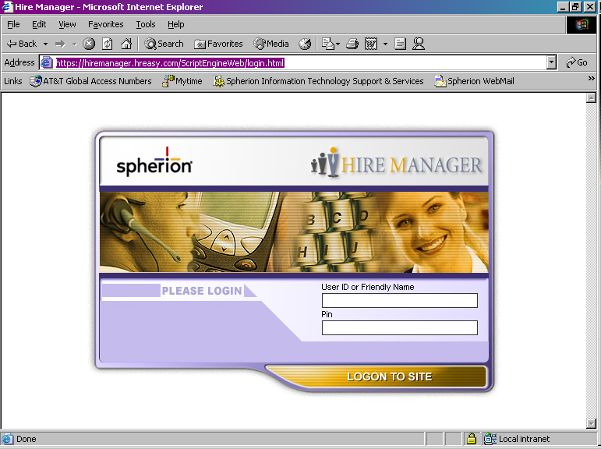

The associate conducting the test will log into the Select Manager application.
- Enter the following login credentials:
- User ID: 2000
- PIN: 9999

- Click LOGIN TO SITE.
The following page will be displayed:

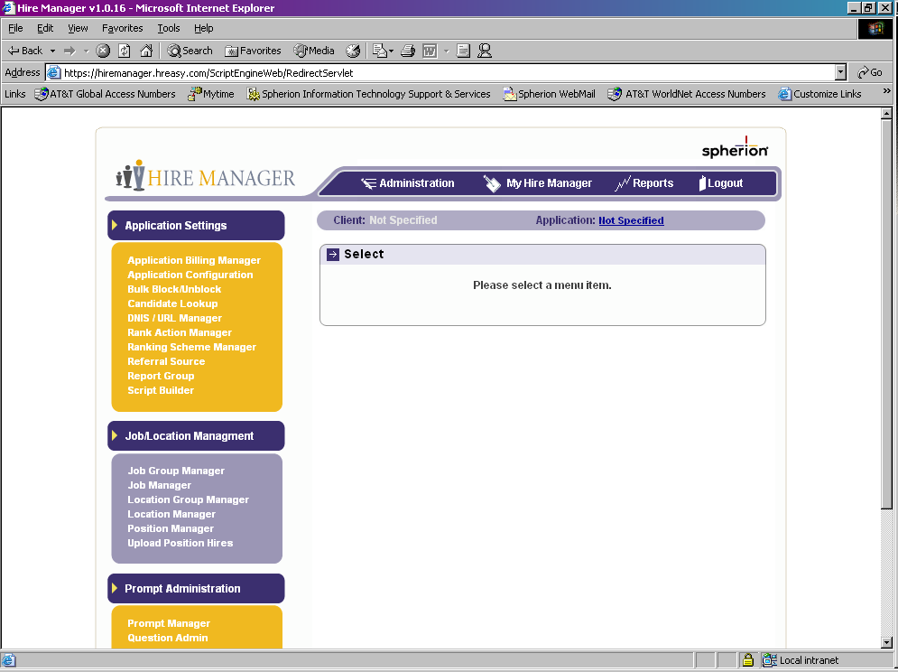
http://selectmanager.hreasy.com/ScriptEngineWeb
http://selectmanager.hreasy.com/ScriptEngineWeb

If the above page is displayed, the Select Manager application is operational.

- The associate who is conducting the test must logout of the system by clicking Logout.

The following screen is displayed:

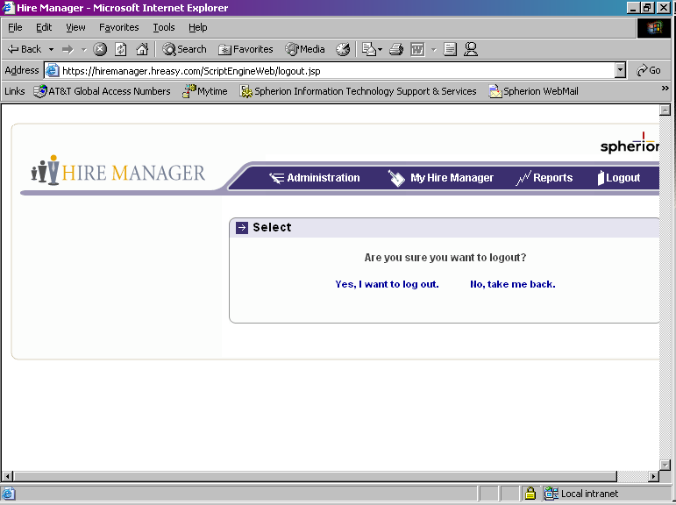
http://selectmanager.hreasy.com/ScriptEngineWeb

The associate conducting the test will select, “Yes, I want to log out.”

Web Assessment Module
To determine if the Web assessment module is operational, the associate conducting the test will use Internet Explorer to access the web assessment test website at

https://secure.hreasy.com/webivr/ivr/?URL=ccctest.url&version=1.0.

The following page will be displayed:

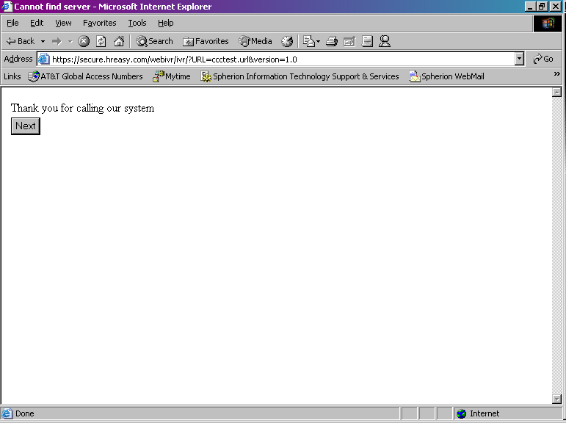
http://selectmanager.hreasy.com/ScriptEngineWeb

If the above page is displayed, the web assessment module is operational.

- Click NEXT.

The following page will be displayed:

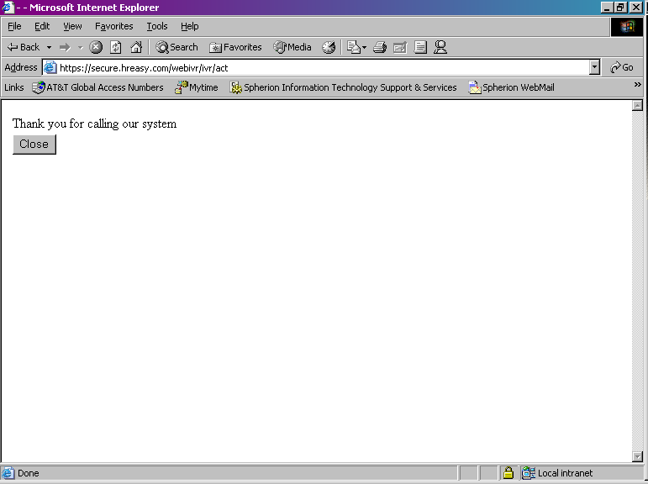
http://selectmanager.hreasy.com/ScriptEngineWeb

- Click Close.

IVR (Telephony) Assessment Module
To determine if the IVR assessment module is operational, the associate conducting the test will dial 954-308-7658.
- At the prompt, “Please enter DNIS followed by the pound key”, enter 2115#.
- At the prompt, “Please enter ANI followed by the pound key”, enter 2115#.
The system is operational if the caller hears the message, “Thank you for calling our system”. (The caller will hear this message 2 times.) At this point, the caller may hang up.

E-Mail Notification (Maintenance Complete)

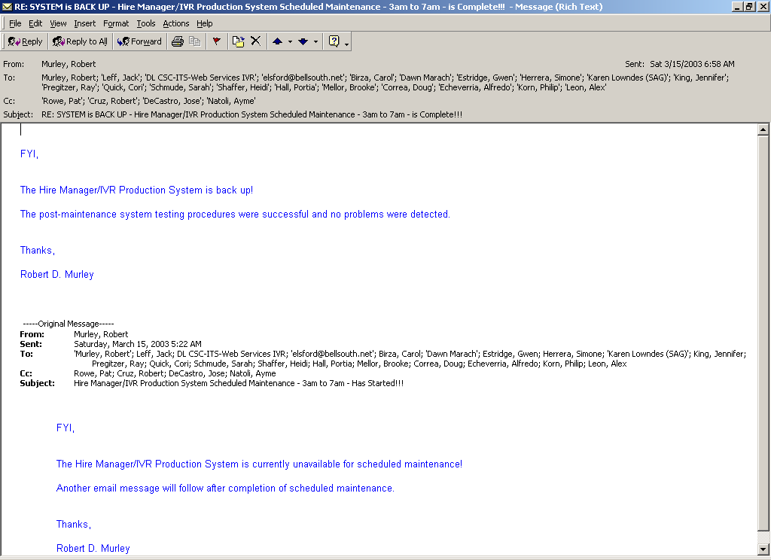

Appendix A — User And Password Information

IVR Production System (cscx0901.core.XYZ.com)
user: wsadmin
password: %W5Adm1n

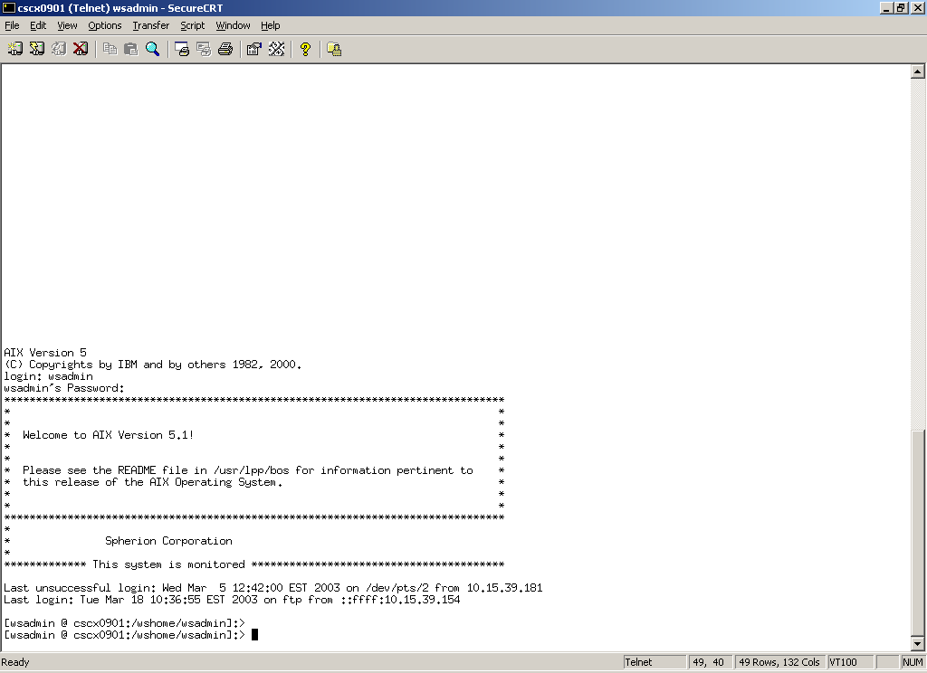

user: dtuser
password: dtu53R

NOTE: Choose Option 2 for command line prompt.



